MiCo

My Instant Container Opener



(Final Prototype Image Here)

**Prepared For:** Shirley Ryan Ability Lab

**Date:** December XXX, 2021

**Submitted By:** Ahmad Alhayek, Isa Candal, Lainey Nelid,

and Nicholas Wolanske

DTC 1, Section 8, Team 1

**Sponsored By:** Design Thinking and Communication

Professors Megan Geigner and Maria Ramos-Tirado

McCormick School of Engineering and Applied Science

Northwestern University

# Executive Summary

Table of Contents

Executive Summary 1

List of Figures 5

List of Tables: 7

Introduction and Background 8

Story of More 8

Design Challenge: Getting a Grip 8

Users and Requirements 8

Main User of the Design 8

Illustrative User Scenario: 9

Main Requirements: 10

Design Concept and Rationale 12

MiCO Overview 12

Heading 1 15

Heading 2 15

Heading 3 15

Final Prototype 16

Limitations 17

Directions for Future Development 18

Conclusion 19

Appendix A: Project Definition 20

Mission Statement 20

Project Deliverables: 20

Constraints 20

Users and Stakeholders: 20

User Profile 21

Illustrative User Scenario 21

​​Project Requirements 22

Appendix B: Research Appendix 23

Primary Research: Project Partner Interview 23

Methodology: 23

Introduction and Project Partners: 23

Overall Needs: 24

Current Solution: 24

User Information and Preferences: 24

Primary Research: Proxy User Interview 25

Secondary Research Summary 27

Overview 27

Anatomy and Kinesiology 27

Stroke and related injuries 30

Existing Solutions 31

Materials 33

Team Discussion 35

Appendix D: User Observation 37

Observation 1: Videos of the User Opening Containers 37

User Observation Summary: 37

Methodology: 37

Information about the User and His Wheelchair: 37

User’s Interactions and Difficulties Opening Containers 38

Discussion 40

Appendix E: Expert Consultations 41

Expert Consolation 1: Interview with Heidi Huckabay 41

Methodology 41

Initial Commentary 41

Mockup Overview 41

Mockup Review 41

Appendix F: Alternatives Matrix 43

Appendix G: Bill of Materials 47

Appendix H: Instructions for Construction 48

Appendix I: Performance Testing 49

Appendix J: Directions for Use 50

Appendix K: Mockup Appendix with User Feedback 51

Methodology: 51

Mockups: 51

Criss Cross Container De Coupler 51

Rocking Ratchet Wrench 53

Zip Time Cup Holder: 55

Rubber Clamp Cup Holder: 57

The Air Pressure Device: 58

The Clasp and Lock: 60

The Tablelike Opener: 61

The Underarm Rest Jar Opener: 62

Iteration: 63

Discussion: 63

Appendix L: Design Review Summary 65

Design Review 1: Feedback from Project Partners 65

Methodology 65

Plan to address these reviews: 66

Acknowledgements 67

References 68

# List of Figures

Figure 1: A CAD Drawing of MiCO 12

Figure 2: The Velcro Strap Used in the Design 12

Figure 3: The EZ Off Jar Opener 13

Figure 4: A View of Hand Anatomy 25

Figure 5: Illustrating Different Types of Grips in Children and Toddlers 26

Figure 6: A View of Power and Precision Grips 27

Figure 7: A Informative Infographic Relating to Stroke [9] 28

Figure 8: A View of the Nerves Extending into the Arm 28

Figure 9: Dycem Non-Slip Self [13] 29

Figure 10: Dycem Non-Slip Cone [14] [15] 29

Figure 11: Under the Cabinet Jar Opener 30

Figure 12: Jar Key Container Opener [14] 30

Figure 13: Automatic Jar Opener [16] 30

Figure 14: Round Silicone Trivets, Pamolon, Round Silicone Trivets, model: YQ-1250 31

Figure 15: A Side View of the De Coupler 49

Figure 16: A Front View of De Coupler 49

Figure 17: A View Inside De Coupler 49

Figure 18: A Top View of the Ratchet Wrench 51

Figure 19: A Side View of the Ratchet Wrench 51

Figure 20: An Angled View of Zip Tie Cup Holder 53

Figure 21: A Front View of Zip Tie Cup Holder 53

Figure 22: A View of the Rubber Clamp Opened 54

Figure 23: A View of a Container Gripped by the Clamp 54

Figure 24:A Top View of the Air Pressure Device 55

Figure 25: A Side View of the Air Pressure Device 55

Figure 26: A Side View of the Air Pressure Device with a Container 56

Figure 27: A Top View of the Air Pressure Device with a Container 56

Figure 28: An Angled View of the Clasp and Lock 57

Figure 29: The Clasp and Lock in Resting Position 57

Figure 30: The Clasp and Lock Engaged 57

Figure 31: A Top View of the Tablelike Opener 58

Figure 32: A Side View of the Tablelike Opener Engaged 58

Figure 33: A Front View of the Underarm Rest Jar Opener 59

Figure 34: A Top View of the Underarm Rest Jar Opener 59

Figure 35: The Underarm Rest Jar Opener Engaged 59

# List of Tables:

Table 2: Project Requirements Summary 21

4. Table 3: User Observations without Dycem: Opportunities, Follow-up, Suggestions 36

Table 4: User Observations with Dycem: Opportunities, Follow-up, Suggestions 38

Table 5: Alternatives Matrix 41

Table 6: Bill of Materials for Mockup Testing 45

Table 7: Design Review Summary 63

# Heading 1

## Heading 2

### Heading 3

#### Heading 4

Format: All spacing is 1.5

Spacing inside table is 1.15

Table headings are bold

Everything is aligned with both sides of page except all tables with are aligned with the left page

# Introduction and Background

## Story of More

In a world where robots have not been trained to open containers, humans face the daunting challenge of opening a pickle jar that just won’t open or a maple syrup jug whose lid has been sealed shut by too many syrupy pours. These tasks are seemingly insurmountable even with the use of two hands and sometimes a kitchen towel, and when limited to just one functioning hand, they become impossible. For many people with conditions that impair their arms, that jar, unfortunately, will remain closed.

## Design Challenge: Getting a Grip

In today's age when we have an app for everything, there does not exist a reliable technology to open containers. Some people have success with Dycem, a material promoted to be anti-slip, but it provides too little grip for others. An automatic jar opener that promised to let a machine replace the wrist only opens a limited range of jars. Every solution has a flaw. Some are too expensive, and others non-portable. Some require a power source, and others are the equivalent of a wet towel. And the worst designs actually still require two hands; they only reduce the force required! Now the time arises to resolve the challenge of creating a device which assists in opening a container with just one hand.

The requirements: a sleek and discrete design that allows the user to open any jar with just one hand; a size that is portable while still being effective. A product which brings joy to the user, bringing independence, and making that favorite PB and J sandwich so much easier to make. A lightness and sturdiness that stands the test of time.

## Users and Requirements

### Main User of the Design

The user, whom we shall refer to as Igor, is an 18-year-old male recovering from spinal cord and nerve damage as a result of gunshot injuries. Paralyzed from the waist down, Igor is confined to his wheelchair. He also has little to no movement of his left arm and reduced functionality of his right arm. Some of Igor's physical limitations include difficulty opening and closing his left hand, no mobility of sensation in his legs, a limited amount of grip strength (10 pounds), and fine motor skills. However, Igor continues to have mobility and sensation on his left shoulder, elbow, and forearm and has control over his right hand, arm, and shoulder. He has no tremors or shaking and can press a lever or a button.

### Illustrative User Scenario:

Igor lives with his mother who can assist in completing certain tasks. However, Igor wants more independence so our device will hopefully help him open containers and jars without help from anyone else. He spends his entire day in his wheelchair so our design should either be able to attach and detach from the wheelchair or be able to be freestanding and small enough he can slip it into his backpack for school.

Currently, when attempt opening a pill bottle, Igor secures the pill bottle between thigh and fingers on left hand. He grasps the top with a functioning right hand and presses against it while twisting with his right wrist. However, since his left hand has no functionality, this does not work, and he fails to open it. To attempt opening a jar of peanut butter, Igor makes use of his elbow crease by placing the jar between his left upper and lower arm. Then he presses against the top and twists right wrist, but it doesn’t work and just slips in his elbow. Unfortunately, Dycem does not solve this problem. Igor uses the Dycem by placing it in the palm of left hand and pressing the jar against it. Then he tries to twist the top off with his right hand and wrist, but it still doesn’t give him enough traction and stability over the jar.

## Main Requirements:

In brainstorming solutions for our user, we compiled a list of needs to help focus our thoughts. The initial criteria we came up with included the characteristics lightweight, portable, subtle, and durable. After talking with Meghan and Randi and learning more about Igor’s experience, we decided that these components were the most important to prioritize in our final design.

After we had this general list of concepts, we expanded upon each constraint. Our team researched similar products to gain a big picture idea about the specifics necessary to consider. In other words, we needed to quantify these qualities.

We started by researching the lightweight attribute. We all understood that the consumer must be able to lift the product with one arm, so we found that the ideal weight for our solution is 500 grams. In this way, we allow for the introduction of sturdy parts to our design. Then we set the maximum weight ceiling at 800 grams, the point at which we decided our product would become too heavy for the user.

In terms of volume, Meghan and Randi told us that our user should be able to carry the product in his backpack. So, we estimated the maximum possible size to be roughly 1,000 cm3, or about 10 cm x 10 cm x 10 cm. Of course, the product would not be a perfect cube, but we hoped that whatever design we came up with, it would be able to fit inside a box of these dimensions and be easily accessible to the hand. Essentially the better it fits in the hand, the more grip the user can gain to procure it from his backpack. Any product larger than 3,375 cm3(or 15 cm x 15 cm x 15 cm) and the product will simply be too big.

Next, our team started to brainstorm the style of our design. Meghan and Randi told us that Igor would not want a flashy design but rather something that is subtle and unobtrusive in form. We concluded that if the product was black or grey it would help keep it discreet. Additionally, we want to prioritize the sleek design to help it blend in in all circumstances and not draw much attention.

In addition to the color and physical design of the object, we realized that those two components do not fully capture Igor’s experience with our product. The sound our product makes will also have an impact on its ultimate reception. Ideally, we wanted our product to make no sound at all, except perhaps the sound of the opening of the actual jar. However, we knew that some existing solutions included a motor or battery that did make some noise. Our team decided the objective, similar to its physical design, was not to call any attention to the user. However, we did allow some leniency in this department, and we set the ideal limit at 0-20 db. While we set the maximum decibel level at 40 db, we realize that at this level, the product will make a sound similar to that of a refrigerator, which, while tolerable, would not be ideal.

Finally, we had to think about the long term uses for our product. It would be quite unhelpful to Igor if it only worked one time. Ultimately, a primary goal for our group was that we create a reliable and durable product. We wanted the product to remain useful for at least three years ideally. Therefore, its parts need to be sturdy and resistant to corrosion. After much debate, we agreed that an allowable lifespan would be 1-2 years because we figured we should allow some flexibility as we set out to test our product. We agreed on a guiding principle in the end: If the overall effectiveness of the product is affected by changes made to increase its durability, the effectiveness should be prioritized.

# Design Concept and Rationale

## MiCO Overview

Now the world can breathe in relief. Introducing MiCO, my instant container opener! Tough-to-open lids are now a thing of the past! This dream device stabilizes any container you can think of and practically opens it for you. From perplexing pickle jars to pesky pill bottles, MiCO will open anything your heart desires. This device revolutionizes existing container opening technology—now entirely portable and adaptable for a wide range of applications.

Figure 1: A CAD Drawing of MiCO

As seen in Figure XXX, MiCO utilizes a sturdy, 15 cm diameter, circular plastic disk that contains a V-shaped depression with metal teeth on one side. This dynamic opening system enables MiCO to grip the lid of many delicious capsules of food as well as medicines. Our lightweight product secures itself underneath the side of any wheelchair arm, using two adjustable Velcro straps, as seen in Figure 2. These straps are durable and dependable, weighing just 15 grams each. They are looped through slots cut into MiCO’s base, ensuring that the opener will never come loose while in use.

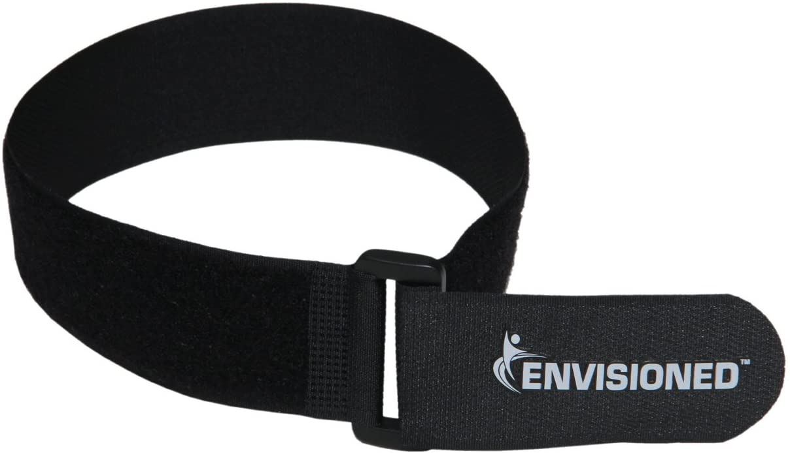

All together, MiCO is super lightweight, weighing only 170 grams with dimensions of 15 cm x 15 cm x 3 cm. An added coating of gray paint will ensure a discreet yet sleek exterior, and a protective, polyethylene foam insert will allow for safe handling when storing it away.

Figure 2: The Velcro Strap Used in the Design

When MiCO is secured to the side of one’s wheelchair (see Figure XXX), all one needs to do is twist open any container with ease. You merely insert the lid into the V-shaped depression, twist clockwise, break the seal, and viola: the lid is loosened. Then simply enjoy the content inside!

Indeed, MiCO is the perfect product for opening containers. Most importantly, MiCO gets the job done, utilizing a versatile and thoroughly tested container opening system to allow the user to loosen lids with just one hand. Furthermore, the sturdy and well-built circular base in combination with the heavy-duty Velcro straps ensures that the product will remain functional for many years. Last, but not least, MiCO is subtle, easily accessible, and painted in a neutral color that won’t draw attention to the product itself. So stop struggling to open containers and get your MiCO today!

## Design Concept

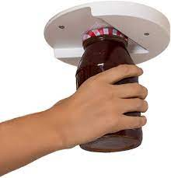Our design concept is the container opener. It will be created in the shop. Our solution is based on an existing solution, the EZ Off Jar Opener, and adapting the device to satisfy our design requirements. In this way, we already know what works and what doesn’t and have a solid starting place, particularly with the physical prototype. We will order the under cabinet opener off of Amazon, seen in Figure XXX, which only costs $15, and then modify it to fit our users’ specific needs. We will make it attachable to his wheelchair with either a 3d printed clasp or Velcro. We will begin to design this attachment with CAD drawings before actually committing to one specific method of attachment. Our first prototype idea can be seen in Figure XXX.

Figure 3: The EZ Off Jar Opener

This product satisfies the requirements because it is small and portable. It is easily attachable and removable to the armrest of a wheelchair via looped Velcro. It is useful for a variety of containers because of the  V-shaped opening and is durable because of the sturdy plastic and metal edge used to grip the container. This product will be discreet because we plan on painting it dark and neutral colors and it does not make any sounds that could bring attention to it. It is an adaptation of a product that works so it should be effective.

# Final Prototype

# Limitations­­­­

# Directions for Future Development

# Conclusion

In general, more performance testing is required in order to reach conclusions on the practically of the existing solution and how our modifications enhance its performance. Specifically, some of the questions we need to answer are as follows:

* Does the device, when used as intended, successfully assist in opening containers?
* Which secures onto the armrest more tightly: backpack straps or Velcro?
* Which is easier to use: backpack straps, Velcro or neither?
* Where is the ideal placement of the device? On the side of the armrest? In front of the armrest? Underneath the armrest?
* How strong is the existing solution? Will it fracture easily?
* How dangerous are the metal blades, really?
* Are there any other modifications we can make, in regard to inherent design, placement, quality, or safety that will enhance the utility of our product?

All of these questions can be answered through multiple methods. We intend to conduct performance testing ourselves. Our group will come up with a rigorous assessment and each group member will conduct the test themselves and fill out the assessment form. Although a small sample, we may pool our data and analyze it to consider making changes to any of the aforementioned states. Additionally, we may create a visual survey for outside, third-party respondents to take, consisting of technical CAD drawings, where we ask them to rate multiple aspects of our designs. Overall, we intend to conduct comprehensive performance analysis in order to maximize the utility of our solution.

# Appendix A: Project Definition

**Project Name:** Assistive Container Opener

**Client:** Shirley Ryan Ability Lab (SRAL)

**Team members:** Ahmad Alhayek,Isa Candal, Lainey Neild, and Nicholas Wolanske

**Date:** December XXX, 2021

## Mission Statement

We aim to improve the user’s ability to open containers with the use of only one arm.

## Project Deliverables:

* Final Report
* Final Prototype / Design Representation
* Final Presentation

## Constraints

* Due Date: December 9th, 2021
* Budget: $100 allocated towards design and prototyping

## Users and Stakeholders:

* The user, whom we shall refer to as Igor, will use the device to open containers independently
* Igor’s mother, who helps him open and close containers
* Mrs. Randi Applehans and Ms. Meghan Griffin, the project partners, are occupational therapists who work with Igor to restore some habitual independence in his life

## User Profile

The user, whom we shall refer to as Igor, is an 18-year-old male recovering from spinal cord and nerve damage as a result of gunshot injuries. Paralyzed from the waist down, Igor is confined to his wheelchair. He also has little to no movement of his left arm and reduced functionality of his right arm. Some of Igor's physical limitations include difficulty opening and closing his left hand, no mobility of sensation in his legs, a limited amount of grip strength (10 pounds), and fine motor skills. However, Igor continues to have mobility and sensation on his left shoulder, elbow, and forearm and has control over his right hand, arm, and shoulder. He has no tremors or shaking and is capable of pressing a lever or a button.

## Illustrative User Scenario

Igor lives with his mother who can assist in completing certain tasks. However, Igor wants more independence so our device will hopefully help him open containers and jars without help from anyone else. He spends his entire day in his wheelchair so our design should either be able to attach and detach from the wheelchair or be able to be freestanding and small enough he can slip it into his backpack for school.

Currently, to attempt opening a pill bottle, Igor secures the pill bottle between thigh and fingers on left hand. He grasps the top with a functioning right hand and presses against it while twisting with his right wrist. However, since his left hand has no functionality, this does not work and he fails to open it. To attempt opening a jar of peanut butter, Igor makes use of his elbow crease by placing the jar between his left upper and lower arm. Then he presses against the top and twists right wrist, but it doesn’t work and just slips in his elbow. Unfortunately, Dycem does not solve this problem. Igor uses the Dycem by placing it in the palm of left hand and pressing the jar against it. Then he tries to twist the top off with his right hand and wrist, but it still doesn’t give him enough traction and stability over the jar.

## ​​Project Requirements

Table 2: Project Requirements Summary

|  |  |  |  |  |
| --- | --- | --- | --- | --- |
| **Needs** | **Metrics** | **Units** | **Ideal value** | **Allowable value** |
| Lightweight product [Can be lifted with one arm] | Weight | g | 500  [Moderately lightweight from experience, allows for the introduction of sturdy pieces] | 800  [Estimate of what would be the threshold for it to become heavy to the user] |
| Portable [Carried in wheelchair or backpack] | Volume | cm3 | 10x10x10  [Doesn’t have to be a cube but a size accessible to the hand, the better fit in his hand the more grip he can have] | 15x15x15  [If bigger, could result in becoming too heavy] |
| Subtle | Colors | - | Black/grey  [Sleek design with not much notability. Must not draw attention] | Colored metals  [Colors should be easy to control but if we do use different metals that are not dark and discrete for a better functionality it is allowable/] |
|  | Noise | db | 0-20  [Ideally the value would be 0 but there is some leniency for some noises to be made. The objective is to not call attention to the user.] | 40  [Sounds like a refrigeration, can bother but still doesn’t call too much attention [1]] |
| Durable | Time | Years | 3  The product should last at least a couple of years. It needs to be sturdy and resistant to corrosion. | 1-2  [Because it is a product that is being tested, we have to allow ourselves some flexibility. If overall effectiveness of the product is affected by changes to better its durability, the effectiveness should be prioritized] |

# Appendix B: Research Appendix

## Primary Research: Project Partner Interview

### Methodology:

On September 23rd, 2021, the team held a Zoom meeting with the project partners Meghan Griffin and Randi Applehans. They are both occupational therapists at Shirley Ryan Ability Lab that work closely with the user. The objective of this meeting was to get insight on our overall purpose and to clarify our existing questions. Several teams presented their questions and created a useful and informative discussion. Teams were given the chance to build up on other’s questions, encouraging a further level of understanding.

### Introduction and Project Partners:

Randi and Meghan are employed at a day rehabilitation center where they help individuals who left a hospital to reintegrate into the community. They aid people with neurological impairments, either stroke, brain injury or spinal cord injury, on their path to regaining their independence in everyday tasks. These may include getting dressed, learning how to cook, or just being an active participant in a society.

### Overall Needs:

The user needs a device which will facilitate the opening of various containers. The user lacks movement in his left arm and has limited hand grip in his right arm resulting in significant in opening containers independently. The device needs to be both versatile and relatively subtle.

### Current Solution:

The user positions their upper arm in such a way as to stabilize the container against their body to open the container with their unaffected hand. The main issue with this technique is that there is no stability, and the container falls and remains unopened. Other methods the user has tried including using his upper arm and chest, which have mobility, to better secure the container, or also using his teeth for plastic that can rip easily. In addition, a material called Dycem is used to stick containers to a surface to help in the process of opening them. However, it is not effective because it does not provide the stability that our user needs in order to apply the amount of force required to succeed at opening the container.

### User Information and Preferences:

The user is an 18-year-old male who has a spinal cord injury. This was a consequence of a gunshot wound. Some of the user’s physical limitations include he is unable to open and close his left hand, his legs are paralyzed with no mobility or sensation, he does not have a large amount of grip strength (10 pounds), and fine motor skills present as a challenge. However, the user continues to have mobility and sensation on his left shoulder, elbow, and forearm and has control over his right hand, arm, and shoulder. He has no tremors or shaking and is capable of pressing a lever or a button.

#### Living Arrangement

Regarding his living situation, he lives with his mother who can assist in completing certain tasks, but the objective is to help him navigate things on his own, to help him regain his independence. The user is on a wheelchair with armrests (the specific model and design will be made available). He is also in high school and needs this device to be portable, compact, and minimalistic.

#### Container

The user desires a product which could open a variety of containers. The user wants the device to be applicable for grooming activities such as opening his toothpaste, which has a small cap, to cooking needs such as opening a jar of peanut butter in the kitchen. The product is not necessary for cardboard boxes or packages. Some of the most challenging containers to open for the user are peanut butter and jelly jars or medication bottles. Easy containers include plastic packages that are easy to rip with his teeth or containers with a push lid.

#### Additional Details

As previously stated, the user desires a product that addresses the challenge of opening different sized containers in a subtle fashion. The product needs to be reusable and accommodate his current living arrangement. Specifically, the user would want the design to be able to detach from the wheelchair and not impede any other functions. Additional constraints will be considered as more primary and secondary information comes to light.

#### Discussion

After reviewing the information obtained, we determined some key points to keep in mind during the design process. Due to the constraints regarding the user’s movement, fine motor skills, and the frequency he will be using this device, it must be light, efficient, and accessible. In terms of design and appearance, the device should be subtle and minimalist looking. However, the device must retain functionality by accommodating a wide variety of containers, ranging in size and shape from a toothpaste tube to a jar of peanut butter. We learned that it is possible to attach the product to the side of the user's wheelchair.

## ­­­­­­

## Primary Research: Proxy User Interview

## Secondary Research Summary

### Overview

The user: our user, whom we will refer to as Igor, is an 18-year-old male who is a casualty of a gunshot, which left him paralyzed from the waist down and with little hand and arm function, especially in his left arm.

### Anatomy and Kinesiology

#### Mechanics of the Hand and Arm

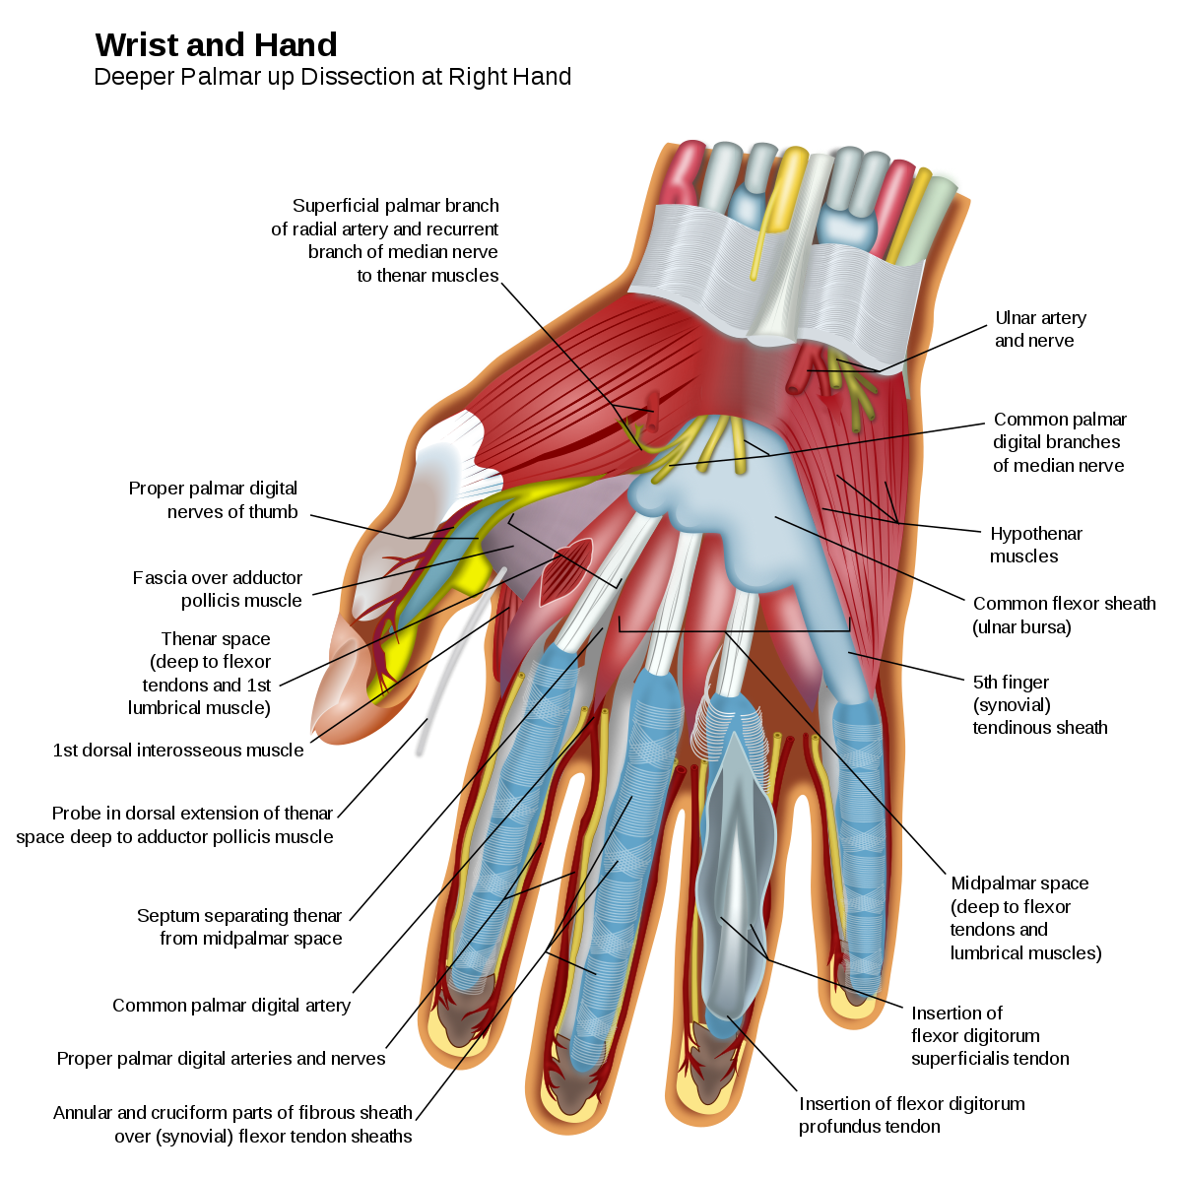The interossei (palmar and dorsal) muscles occupy the space between the bones of the hand [1]. Dorsal interossei allow the fingers to spread away from each other, and palmar interossei pull the fingers together. The hypothenar muscle group forms the bulk of the pinky-finger side of the hand. These muscles allow for independent movement of the pinky finger, cupping of hands, and bending of the fingers at the joints. Thenar muscles consist of the area around the thumb (see Figure XXX for muscles of the hand). The opponens pollicis allow the hand to grasp, which is one of the most important functions of the human hand. Lumbrical muscles allow the fingers to bend and straighten. Forearm movement occurs when the radius wraps around the ulna. Guided by tissue in the elbow and joints, this contributes to upper extremity mobility. In some motions, forces at the elbow can exceed several times the entire body weight [2]. The shoulder is composed of a “chain” of 18 muscles, which act in synergy [3]. Interactions between the radius, ulna, shoulder, and hand create motion, stability and force interactions that allow for the function of the arm.

Figure 4: A View of Hand Anatomy

#### Grips and Grip Strength

Males today have an average of 99 and 101 pounds of grip strength in their right and left hands, respectively [4]. Grip strength increases exponentially from childhood to adulthood, and wanes in elderly age. Physical and occupational therapists measure grip strength as a way to assess hand functionality and recovery. Grip strength also varies depending on the position of the arm. A 90-degree flexion of the elbow, as opposed to fully extended, corresponds to higher grip strength [5]. Osteoarthritis, a common rheumatic disease associated with damage of cartilage and bone, has been widely studied and associated with decreases in grip strength and ability to perform manual activities. The Mayo Clinic notes that gripping a device, such as a toothbrush, with larger handles may make doing that activity easier [6]. Moreover, a study in chimpanzees found that power grips were more effective with a larger object (which in this study was a grape) [7].

#### Types of Grips

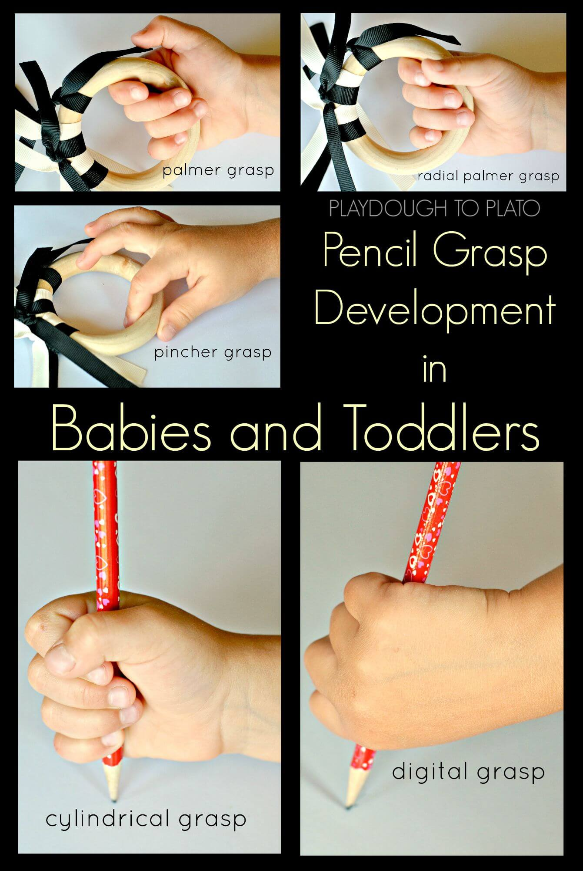Development of motor skills through childhood into adulthood can be characterized by utilization of different types of grips. Children most frequently manipulate objects with fisted and palmer grips, which use early fine motor skills and require motion of the whole arm [5]. As children age, motor skills develop, and gripping/grasping techniques become more refined (see Figure XXX). These types of grasps require minimal elbow and shoulder movement, and primary control comes from the wrist and fingers.

Figure 5: Illustrating Different Types of Grips in Children and Toddlers

There are two main types of grips: power grasp and precision grasp [1]. In the power grasp, the adductor pollicis stabilizes an object against the palm with a stationary hand. Cylindrical, spherical, and hook grips fall under the umbrella of the power grasp (see Figure XXX). In the precision grip, the hand is dynamic. Muscles are active that abduct or oppose the thumb. Precision grips include tripod, tip-to-tip, and lateral prehension.

#### Overcoming Limitations to Movement

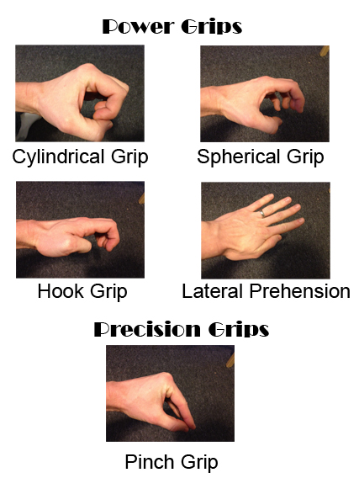Arthritis, which is inflammation of the joints, hinders movement and rotations. According to the CDC, 54 million Americans, or about 1 in every 4 adults, suffer from arthritis [8]. Occupational therapists and doctors have developed techniques to aid those with arthritis in opening and closing jars. Some of the techniques are as follows:

* Holding the jar closer to the individual’s body utilizes other, larger muscles
* Wearing rubber gloves allows for more resistance between the hand and the surface, increasing grip strength
* Wrapping the jar in a towel or washcloth keeps the hand from slipping and provides additional grip
* Using smaller containers allows for a smaller surface area to hand ratio, which makes them easier to open

Figure 6: A View of Power and Precision Grips

* Training grip strength with a handheld device or physical therapy.

#### Conclusion

When designing a product intended to assist people with limited hand and arm mobility, the design team must consider the amount of grip strength the user has. A device that requires more grip strength than the user possesses is rendered useless. Moreover, the angle and position of the device must be considered, to maximize use of torque, gravity, and other muscles.

### Stroke and related injuries

#### Injuries Frequently Resulting in Monoplegia

A number of various injuries and conditions cause monoplegia, paralysis in one arm. Monoplegia is often interlinked with hemiplegia, weakness of one entire side of the body [10].

#### Background on Stroke

Stroke remains the leading cause of monoplegia and hemiplegia [10]. A stroke happens when an interruption occurs to the blood supply of the brain. Brain cells do not receive the oxygen or nutrients they require and die off, potentially resulting in paralysis and loss of motor function. Strokes are generally classified in two forms, ischemic and hemorrhagic; ischemic strokes are caused by a blockage in a blood vessel supplying the brain while hemorrhagic strokes occur when there is bleeding into the brain [10]. The majority of strokes, 87%, are Ischemic, with a significant portion of them, roughly one in three, of unknown cause, see Figure 4. Due to the varying nature of strokes, in both type and location, one cannot generalize the effects of a stroke on a person [10].

Figure 7: An Informative Infographic Relating to Stroke [9]

#### Effects of Stroke

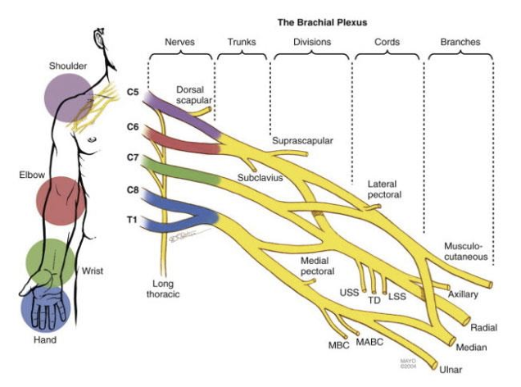Second to stroke in frequency, trauma to the brachial plexus is another leading cause of monoplegia [11][18]. The brachial plexus is a series of nerves that extend from the spinal cord down to the shoulder, arm, and hand. When damaged, individuals could experience arm paralysis, lack of muscle control or a lack of sensation in the arm, hand or wrist [11]. Similar to stroke, there is a wide spectrum of injury involving the brachial plexus. Avulsion, the most severe type of injury, occurs when the nerve is ripped or cut from the spinal cord. On the opposite side of the spectrum is neuropraxia, a stretch injury, in which the protective covering of the nerve is damaged, yet the nerve itself may still be fully functional [12].

Figure 8: A View of the Nerves Extending into the Arm

Although injury to the brachial plexus can occur through a multitude of accidents, missile injuries (bullet wounds) are the second most common cause of brachial plexus injuries [12][18]. Missile wounds cause nerve damage as the body experiences shock waves, cavitation, and sometimes a direct impact to the nerve cords [12].

### Existing Solutions

#### Dycem Non-Slip Self, Adhesive Material

This design, shown in figure 6, is essentially sticky material that someone can wrap around their arm and use to stabilize the jar opening process. You can hold the jar’s lid against this sticky material on your arm and use your other hand to turn. It is an effective design, but the drawback is you add another whole step of applying the wrap to your arm. Then, after you open the jar, you have to take the wrap off. Additionally, if there was a liquid inside of the jar, it might spill due to the unusual angle. [13]

Figure 9: Dycem Non-Slip Self [13]

#### Dycem Non-Slip Cone-Shaped Bottle Opener

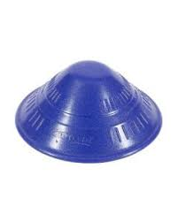This design, shown in Figure XXX, is one of the better ones on the market. It is small, portable, and non-battery operated. You can store it in your kitchen or take it with you when you travel. The only significant drawback is it is not that efficient. It works by creating a better grip on the jar’s lid. You apply it directly over the lid and then twist, but there is nothing to stabilize the jar, so the user is still compelled to stick the jar between their legs or under their arm for use. [14] It merely serves to make the opening a little bit easier, but it is nowhere near as effective as the built-in at-home devices. Additionally, if the user does not have control of their legs, it is practically useless. [15]

Figure 10: Dycem Non-Slip Cone [14] [15]

#### Under Cabinet Jar Lid & Bottle Opener

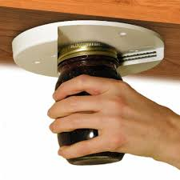This product, shown in figure 8, is a container opener that is fastened under a cabinet or container. This solution is arguably the closest solution to what would work for our user. In this design, the user can open multiple sized containers. Additionally, only one functioning arm and hand is required to use this whereas most of the other solutions require two functioning hands. Additionally, this solution is subtle (installed under a tabletop), does not require a battery, and is reusable. The only drawback is that it is not mobile. So, if the user wanted to open a container out at a restaurant, or at school, or in any environment that is not his house, he could not. [15]

Figure 11: Under the Cabinet Jar Opener

#### Jar Key Container Opener

The design of this solution was originally intended with people who have some functionality in both arms and hands but just limited hand strength, for example, a user with. So, this solution would not work for our user. However, it has components that our team might want to incorporate into the design. This design is the smallest and most lightweight. It would be perfect to slip into a backpack and take anywhere. Additionally, it is reusable and does not require any type of motor. [14]

Figure 12: Jar Key Container Opener [14]

#### Automatic Jar Opener

This jar opener looks like a spaceship as it is cumbersome and bulky. It will take up a great deal of space in our user's kitchen cupboard and will not be convenient to carry in his backpack. Additionally, it requires a power source, such as batteries. While the mechanism is effective, its drawbacks in terms of size and power-source are considerable. Moreover, it only works for a finite number of container sizes and is very loud when in use. It is also more expensive than any of the other solutions. So, although this solution only requires one functioning arm and hand, it is more expensive, more noisy, less versatile, and heavier. [15]

Figure 13: Automatic Jar Opener [16]

### Materials

When conducting an investigation on the possible materials, we decided to consider various different compounds. It was a broad look that will help us narrow down the multiple options and combinations. For this process we had to keep some ideas present so that we didn’t deviate from the original purpose. Materials should serve in favor of the product, which means they have to be complacent with some main characteristics. For example, the product should be easily portable. This means it has to be lightweight while still being strong and sturdy enough to apply force to it. It will also be used in different environments, like the bathroom and the kitchen, so it should be easily cleanable and disinfected. Furthermore, durability is also a factor to consider. One time use materials like cardboard, or thin plastic should be explored in order to be improved upon or considered a last resort due to economic restrictions as cost is another important variable in this project.

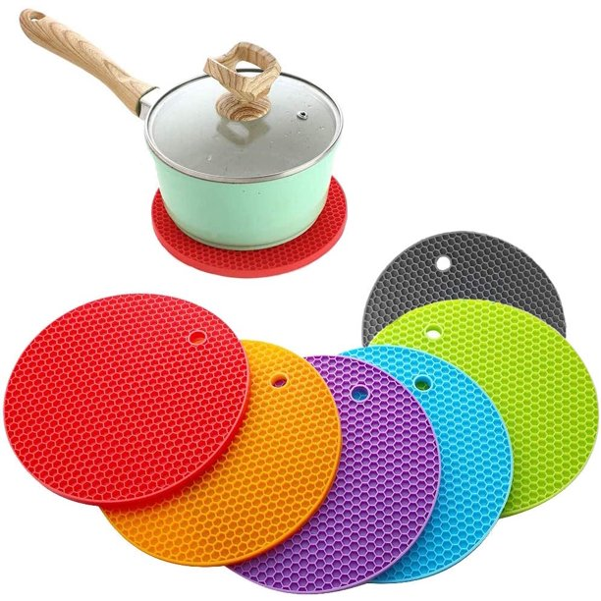In addition, grip strength is a very important characteristic to consider when it comes to choosing materials. There are several ideas to consider within this category like the physical manipulation of the material. For instance, the addition of ridges or crevices, or the lengths and angles that can be determined to optimize the grip strength. The material could also contribute its own adhesive or non-slip properties. Silicone is a good material for this particular reason. It already exists as a solution to prevent slipping, but we would need to modify it to fit our needs. [19]

Figure 14: Round Silicone Trivets, Pamolon, Round Silicone Trivets, model: YQ-1250

In Figure XXX, we can notice that the silicone contributes to the non-slip properties of silicon while also incorporating textural differences to increase the overall grip strength.

A study for the “Grip strength changes in relation to different body postures, elbow and forearm positions”, conducted in 2013, showed that changes in the position of one’s hand can impact the amount of grip strength used to conduct everyday tasks. [20] A conclusion that we can take into consideration was that one produces more grip strength when the elbow is extended. Simple changes like this in the behavior of the patient could potentially be beneficial to the effectiveness of the product by increasing the ultimate output of strength. This means that we can produce a product that uses materials and shapes that optimize human performance in the area of need.

#### General Possible Materials

* Aluminum: Compared to other metals it is lighter. Its alloys produce stronger compounds. [21] It is insensitive to cold work, which means it requires heat and molds in order to achieve desired shapes. This means that it needs the appropriate tools which demand training and higher costs. Small pieces bought in the correct shape could be utilized.
* PVC: Otherwise known as Polyvinyl Chloride. [22] It is a hard, durable material that is sold in multiple sizes. Regarding costs, it lies on the cheaper side and might be a good material to make mockups. Easily moldable with heat. It is lightweight and sturdy. It is also easy to clean.
* Wood: Compared to other materials it lacks the strength and ability to be cleaned. It would require the reapplication of oils in order to maintain its durability and is ultimately not the best material for this purpose.
* Silicone: Non-slip properties. “Silicone rubber compounds were easy to process, require no expensive equipment and have adjustable working times and cure rates.” [23] It is accessible to us and easily moldable.
* Non-slip coatings: a spray that adheres to given surfaces in order to make them more graspable to the person or to the container. [24] Commercial uses for these are mostly for floors and streets to prevent people from slipping but could be applied in the product in specific regions to increase the grip strength of that particular area.

#### Conclusion on Materials

It is important to consider efficiency and effectiveness when it comes down to selecting appropriate materials. Combinations of different materials can increase both of these properties. Selecting silicone, for instance, paired with PVC or aluminum could yield a sturdier and highly graspable product than them on their own. We could also introduce other material combinations that contribute other physical properties, for instance, magnets. Clasps could also be used to attach the device to the container to aid in gripping it. There are endless combinations of materials that could improve the overall design, but in this case, it is important to keep in mind the costs and benefits that every material has. As stated previously, the material is there to serve a purpose to achieve the end goal. While aesthetics is important to consider, they are not the main priority as long as the device is portable and works.

### Team Discussion

After gathering this information, we understand the importance and relevance of comprehending the situation to the fullest extent with secondary sources. It was important to analyze the problem from different angles, from medical to more technical, in order to gain a wider perspective on the problem and the possible solutions. We can now further understand the limitations of hand paralysis and reduced grip strength, the impact of damage to the brachial nexus, and existing solutions that could help us develop our own ideas. It is key to keep these ideas present during every stage, to reflect and rely on previously gathered sources to substantiate our ideas. This secondary research creates a base for us to use our creativity at its fullest while being grounded and on topic.

# Appendix D: User Observation

## Observation 1: Videos of the User Opening Containers

### User Observation Summary:

Ahmad Alhayek, Isa Candal, Nicholas Wolanske, and Lainey Neild observed footage taken by occupational therapists (OTs) Randi Applehans and Meghan Griffin at Shirley Ryan Ability Lab (SRAL) in the first week of October 2021. The purpose of this recorded footage was to understand how the user maneuvers around in his wheelchair, uses his arms, and opens jars and other containers. These videos last a cumulative 79 seconds. This appendix details the methodology used to conduct the observation, describes the user’s current mobilities and limitations, and summarizes the results of the observation.

### Methodology:

This observation took place remotely, but the videos were filmed at Shirley Ryan Ability Lab in Chicago, Illinois. Meghan and Randi also sent answers to questions we had via email.

### Information about the User and His Wheelchair:

The user, whom we shall refer to as Igor, is an 18-year-old male recovering from spinal cord and nerve damage as a result of gunshot injuries. Paralyzed from the waist down, Igor is confined to his wheelchair. He also has little to no movement of his left arm (only being able to move his shoulder) and reduced functionality of his right arm. Thus, Igor has difficulty opening jars, cans, containers, pill bottles, etc.

The wheelchair is the model Shoprider XLR 14 PowerTilt Power Chair.

The characteristics of the wheelchair pertaining specifically to opening containers include:

* The armrests are independent from the front: something can be slipped in if necessary.
* Dimensions of wheelchair arm: length: 45cm, Width: 10cm
* The distance between the top of the wheelchair arm and the user's lap when sitting in the wheelchair is 18cm.
* It had a footrest, which could be useful for support.
* There is storage space in the back. It is not very large, but it could accommodate a discreetly sized product.

### User’s Interactions and Difficulties Opening Containers

#### Process of Opening a Pill Bottle:

1. Secures pill bottle between thigh and fingers on left hand
2. Grasps top with functioning right hand
3. Presses against top and twists right wrist; does not work
4. Changes position to press bottle against left palm and twist; does not work
5. User fails to open pill bottle

#### Process of Opening a Jar of Peanut Butter with Elbow

1. Places jar between left upper and lower arms (in elbow crease)
2. Presses against top and twists right wrist
3. User fails to open the jar
4. Table 3: User Observations without Dycem: Opportunities, Follow-up, Suggestions

|  |  |  |
| --- | --- | --- |
| **Observations** | **Opportunities** | **Follow-up** |
| User has difficulty getting container in a fixed position - attempts to secure it between legs, bended left arm, with left hand | Find a way to keep container and / or lid fixed in place | Consider designs to keep either the container or lid fixed in place for the user |
| Grasps top of containers with right hand, | Investigate if the grip used is optimal for opening containers | Consider grip alternative when grasping top, possibility of using a glove |
| Attempts to open lid, containers slip due to no secure grip on bottom half | By holding the container and / or lid in place, the user should be able to open the container | Combining the two ideas outlined above, a sturdy grip + fixed container / lid would allow the user to open the container |

#### Process of Opening a Jar of Peanut Butter with an Existing Solution, Dycem

1. Places Dycem (sticky material; shaped like ribbon (approximately 5 cm wide and 30 cm long)) in palm of left hand
2. Pushes bottom of jar against Dycem
3. Twists top with right hand and wrist
4. User fails to open the jar

Table 4: User Observations with Dycem: Opportunities, Follow-up, Suggestions

|  |  |  |
| --- | --- | --- |
| **Observations** | **Opportunities** | **Follow-up** |
| User has difficulty attaching Dycem between the container and left hand | Similar as previous table: find a way to keep container and / or lid fixed in place | Consider why Dycem isn’t sticking. How can our design avoid the same problem? |
| Grasps top of containers with right hand, palm grip on lid (abduction of hand) | Find a way to improve grip strength on lid of jar | As mentioned before, consider grip alternatives, glove, and other adhesive material |
| Attempts to open lid, containers slips less due to Dycem, however not firm enough grip to open container | The Dycem solution almost worked. Improving how the jar is held down would allow for the user to successfully turn the lid. | Our group should consider if trying to improve the Dycem is a good design route. Can we use the existing product in some way or design one that is better? |

### Discussion

From these videos we can understand in a better way the difficulties in the process of opening containers and the position of the user with regards to the wheelchair. We need to find a way to help in a way that the existing solutions he is using aren’t. The Dycem on its own is not effective but it may be employed or integrated into another product to increase its effectiveness. We could also see that the user has space around his armrest and could move comfortably between the arm rests. There are many opportunities to explore different ideas after completing these observations because they will help keep us grounded and realistic about the possible products.

# Appendix E: Expert Consultations

## Expert Consolation 1: Interview with Heidi Huckabay

### Methodology

On Monday, October 18th, 2021, the team held an in-person meeting with shop expert Heidi Huckaby, a prototyping specialist at the Segal Design Institute at Northwestern. The objective of this meeting was to get insight on mockup design, including material choice, fabrication methods, and questions regarding functionality. Team members presented their initial mockups to her and sought insight on the aforementioned topics.

### Initial Commentary

The team explained the overall nature of the project and limiting factors and considerations when devising a solution. The team then gave a quick overview of the research conducted so far in addition to previous solutions under considerations. With a firm background established, the team then moved on to mockups.

### Mockup Overview

Heidi emphasized that mockups, especially in the early stages of design, need not be entirely complex. She recommended using cardboard, foam board, and other simple materials found throughout the shop to make the initial mockups. She then gave us a brief tour of the shop, informing us where these materials and tools are located for initial mockups. This tour was particularly insightful in relation to informing us about the cabinets in the backroom of the shop which contains more specialized hardware that might significantly improve our mockups.

### Mockup Review

The team then presented Heidi with some initial mockups in preparation for our meeting with the professors on the following day. Each team member explained the initial idea of their mockup in addition to a sketch of it. For each mockup, Heidi made some material in addition to overall design commentary. In review of Ahmad’s mockup, she pointed out the potential for a conical shape design to get a more versatile gripping mechanism for the containers. Furthermore, she then also observed the large potential for overlap between each team member’s proposed mockups, which sparked a discussion on collaboration between our mockups. Both insights were incredibly helpful for our team as we underwent the mockup fabrication portion of our project. We then discussed future steps for mockups, including mockup testing and finally finished the meeting by discussing future availability for another consultation.

# Appendix F: Alternatives Matrix

Table 5: Alternatives Matrix

|  |  |  |  |  |  |
| --- | --- | --- | --- | --- | --- |
| **Requirements** | **Under Cabinet Opener:** With attachability to his arm rest | **Tablelike Stabilizer:** (sticky with independent for lid base); attaches to both armrests - use other hand to open if bottle is stable | **Container Clamp:** Normally fixed to wheelchair but can be removed, very versatile in container size. Limited assistance in lid opening. | **Horizontal Container Clamp**: Place container on base and pushing spring loaded sides closed to grip container. Container is released by button on bottom. | **Clasp and lock:** attachment to the caps or tops of containers, hand attachment and twist. |
| Opens various containers | X |  | X | X | X |
| Used with one hand | X | X | X | X | X |
| Small, fits in backpack | X |  | X | X | X |
| Minimalistic Looking and Subtle | X |  |  | X | X |
| Lightweight | X | X |  | X | X |
| Wheelchair attached (optional) | X | X | X | X |  |
| Durable | X | X | X | X | X |
| Safe to Use | X | X | X | X | X |
| Good grip |  | X | X | X | X |
| Easy to clean | X |  | X |  | X |
| Works for screw off lids | X | X | X | X | X |
| Works for pill bottle lids | X | X | X | X | X |
| Works for pop off lids | X | X | X | X | X |
| Works with toothpaste containers | X |  |  | X |  |
| Total | 13 | 9 | 11 | 12 | 12 |

|  |  |  |  |  |  |  |
| --- | --- | --- | --- | --- | --- | --- |
| **Requirements** | **The adjustable opener:** Circular hollow container with an adjustable metal inside that adapts to the container. Uses torque to help with opening the container | **Under armrest opener:** flat attachment with "teeth" that make a V shape. Grasps onto lid of container and user twists to open container | **The Belt:** adjustable "belt" with Dycem or other sticky material on the inside; adjusts to fit radius of different containers | **Extra Hand**: A hand that attaches to the arm rest. Fingers and thumbs can be moved to adjust to any jar to hold it still. Then there is a locking mechanism to hold it all still. | **Sock Holder:** a sock like material that stretches around any type of jar and is tight enough that it holds the jar story. Stabilizes while the user opens the lid. | **Dycem Hand Glove**: Fixed position glove which the user puts on his left hand and then can adjust the grip using his right hand |
| Opens various containers | X | X | X | X | X | X |
| Used with one hand | X | X |  | X | X |  |
| Small, fits in backpack | X | X | X | X | X | X |
| Minimalistic Looking and Subtle | X | X | X | X | X | X |
| Lightweight | X |  | X | X | X | X |
| Wheelchair attached (optional) |  | X |  | X | X |  |
| Durable | X | X | X |  |  | X |
| Safe to Use |  | X | X | X | X | X |
| Good grip | X | X | X | X |  | X |
| Easy to clean | X | X | X |  |  | X |
| Works for screw off lids | X | X | X | X | X | X |
| Works for pill bottle lids |  |  | X | X |  |  |
| Works for pop off lids |  | X | X | X |  | X |
| Works with toothpaste | X |  | X |  |  |  |
| Total | 10 | 11 | 11 | 11 | 8 | 10 |

|  |  |  |  |  |
| --- | --- | --- | --- | --- |
| **Requirements** | **Inflatable Container Holder**: Circular inflatable bag arrangement (think blood pressure checking device) that will grip the container in a fixed position. | **Fixed Horizontal Clamp:** Attached to wheelchair and clamps onto the bottom of containers. Uses a locking mechanism to remain in place. | **The octopus holder:** Multiple "arms" that attach to the container via suction and hold it steady close to a base. | **The Wind-it-up:** Uses tensile strength, like in kid’s toys, where you wind it up and then it uses that force to spin in the opposite direction opening the lid. |
| Opens various containers | X | X | X | X |
| Used with one hand | X | X | X | X |
| Small, fits in backpack |  | X | X | X |
| Minimalistic Looking and Subtle | X | X |  | X |
| Lightweight | X | X | X | X |
| Wheelchair attached (optional) | X | X | X |  |
| Durable |  | X | X | X |
| Safe to Use | X | X | X | X |
| Good grip | X |  | X | X |
| Easy to clean |  |  | X | X |
| Works for screw off lids | X | X | X |  |
| Works for pill bottle lids | X | X | X |  |
| Works for pop off lids | X | X | X |  |
| Works with toothpaste containers |  | X |  | X |
| Total | 10 | 12 | 12 | 10 |

# Appendix G: Bill of Materials

Table 6: Bill of Materials for Mockup Testing

|  |  |  |  |  |  |
| --- | --- | --- | --- | --- | --- |
| **Item** | **Description of Purchase** | **Qty** | **Source** | **Part number** | **Cost** |
| EZ Off Jar Opener | EZ OFF Jar Opener: EZ Off will grab hold of any lid whether its factory sealed, child proof, tamper proof or just stuck from what's inside the jar. A simple twist and The EZ Off Jar Opener will deliver | 1 | [Amazon](https://www.amazon.com/EZ-Off-Opener-Sizes-White/dp/B000X6K9J8) | B000X6K9J8 | $14.87 |
| Envisioned Velcro Straps | Envisioned Velcro Straps: Constructed of durable, strong gripping hook and loop nylon material, these adjustable, reusable and multi-purpose cinch straps are easy to use and hold strong! Perfect for organizing and securing items in your home, garage, office, vehicle, for camping and outdoors. | 1 | [Amazon](https://www.amazon.com/Reusable-Cinch-Straps-30-Multipurpose/dp/B01G4IVLC2/ref=sr_1_16?keywords=velcro%2Bloop%2Bstraps&qid=1636670810&qsid=143-9282443-7067840&sr=8-16&sres=B0798L21FG%2CB08MZYWQ3L%2CB001E1Y5O6%2CB07SMD8QVH%2CB00JWU77N2%2CB00006IC2R%2CB07CZGQNY3%2CB08JQ6XWR2%2CB07FMTZ5RM%2CB097BG9Q9F%2CB00QMMKY8I%2CB07GTV7PJK%2CB07FY7T1WL%2CB08PK7ZXBX%2CB079BGB97Z%2CB0721RLH3V&th=1) | B01G4IVLC2 | $15.87 |
| **Total Cost:** | | | | | $30.74 |

# Appendix H: Instructions for Construction

# Appendix I: Performance Testing

# Appendix J: Directions for Use

# Appendix K: Mockup Appendix with User Feedback

## Methodology:

We recorded short videos in the Ford Engineering Building at Northwestern University of our mockups in use with detailed descriptions, narrations, and questions for the occupational therapists, and forwarded them to Meghan and Randi at Shirley-Ryan Ability Lab in Chicago, Il. They responded to our videos in further correspondence via email and provided comments (relayed in quotes) and answers to our questions. Meghan and Randi also included pros and cons lists for each concept.

## Mockups:

### Criss Cross Container De Coupler

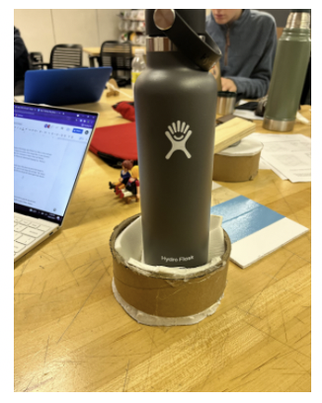The Criss Cross Container De Coupler combines two identical conical shaped parts to open a container. One part is a base to secure the container, and the other is coated in sticky or friction-inducing material to create friction to help open the lid (see Figures XXX and XXX). This concept serves as a simple way to open many different containers. As shown in Figure XXX, the conical shape of the base and top fit containers of varying radii, which helps the user open anything from toothpaste to pill bottles. Furthermore, the concept allows the user to operate it with only one hand, since the base will attach to the wheelchair armrest via suction cups. This device meets the portability requirement because it is also compact and can be stowed away, instead of remaining permanently attached to the wheelchair.

Figure 16: A Front View of De Coupler

#### Feedback:

After hearing back from Meghan and Randi, we analyzed the pros and cons of the Criss Cross Container de Coupler. This device’s particular advantage was its ability to open a wide range of varying containers. The size of this product allows it to be stored in the user's backpack, but it would take up almost all the space in the backpack. Additionally, the unique conical lid design was particularly useful in that it allowed for all sizes of jars and containers to be opened. The central concept of using two pieces—one study base, one cone lid—is a compelling aspect of the design, as it allowed for a wide range of base and lid sizes.

Figure 17: A View Inside De Coupler

The major drawback of this design is it is simply too large in size, and Meghan and Randi wondered where the user would store the parts for easy access. The Criss Cross Container de Coupler would take up a fair bit of space anywhere they were stored. Another con we observed was how the user would not want to keep both sides of the device attached during the day since it would be in the way of carrying things in his lap or using his hands or bending forward. He would only attach it when he needs to open something. So, we concluded that a device that was attached to one arm rest would be a more suitable solution for Igor.

Our project partners also gave us feedback on some questions we had regarding our user’s hypothetical experience with this device. Meghan and Randi told us they were hoping for a design solution to fit onto the wheelchair’s armrest. One question our team had was: Could the user grip the ratcheting part with his palm? They told us that they believed Igot would most likely be able to grip the ratcheting part. However, Meghan and Randi said that if the device was smaller, it would allow Igor to grip it more tightly. Another question our team considered: Is the user able to work more of his upper body muscles into the movement? Meghan and Randi explained that Igor favors his right upper arm muscles when opening containers which gave us more perspective in creating our final design.

### Rocking Ratchet Wrench

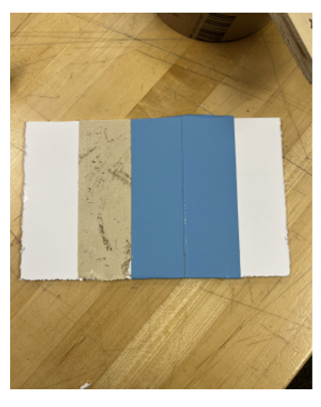This central concept of this design employs two parts: a sticky base and an attaching ratchet to open the container, similar to the Criss Cross Container de Coupler. The conical structure of the attaching part of the ratchet, as shown in Figure XXX, provides a strong frictional force and the capacity to open containers of varying radii. This solution meets the needs of the design by attaching firmly to all sizes of containers (Figure XXX) and entailing a one-handed motion. The ergonomic handle allows the user to grasp the device comfortably and leverage the length of the lever arm for more torque. This solution also enables the user to put more of their upper body muscles into the motions, since it is more of a push rather than an exercise in fine motor skills (Figure XXX). Moreover, the user has total control of the motion and can easily adjust the force and speed.

Figure 19: A Side View of the Ratchet Wrench

Figure 18: A Top View of the Ratchet Wrench

#### Feedback:

Meghan and Randi did not find this product useful. Ultimately, they did not see any pros to the design at all. They basically found only the bottom grip surface useful. They thought the handle was too heavy to handle. Meghan said, “I think the user could open the jar with just the grip surface on the bottom. He may just prefer to use his hand to open it if the base was keeping the jar still.” Because Meghan and Randi were so fundamentally unimpressed with this design, we did not ask them any further questions in regard to this design concept.

### Zip Time Cup Holder:

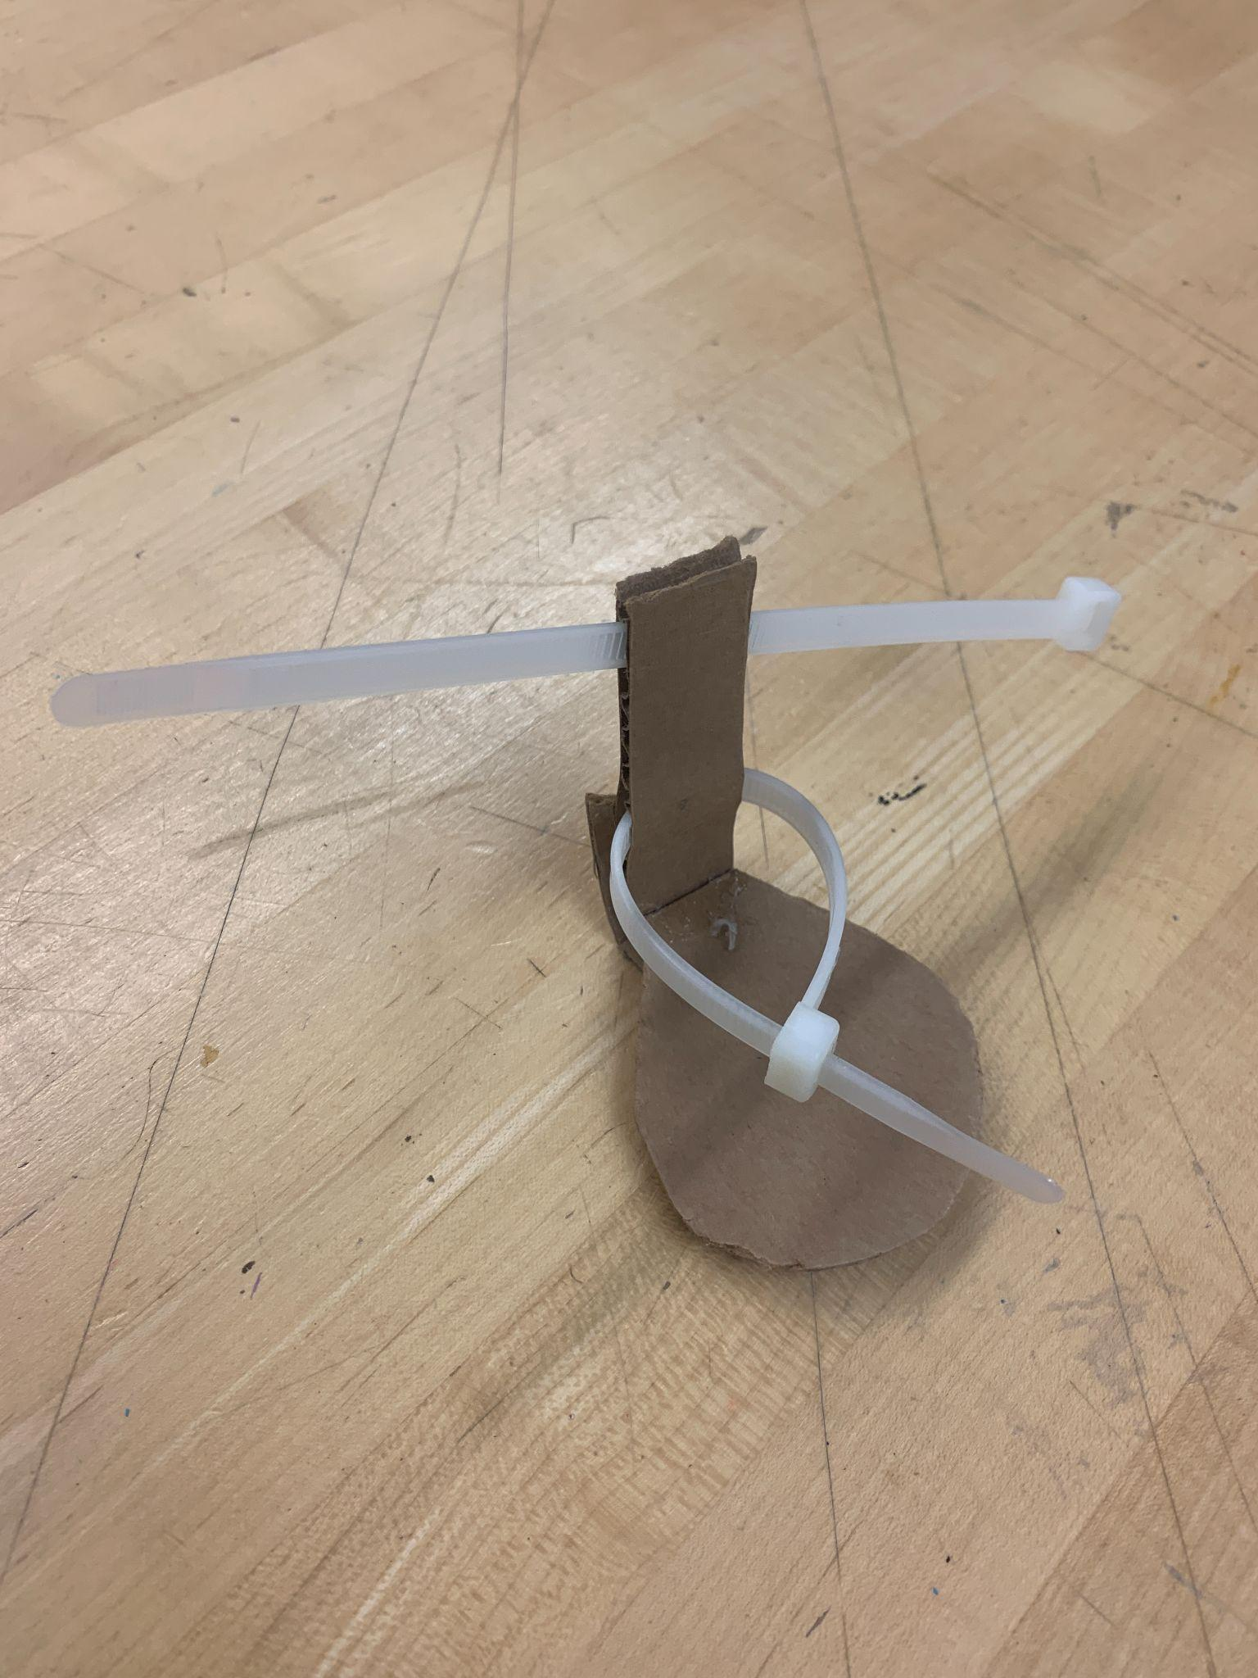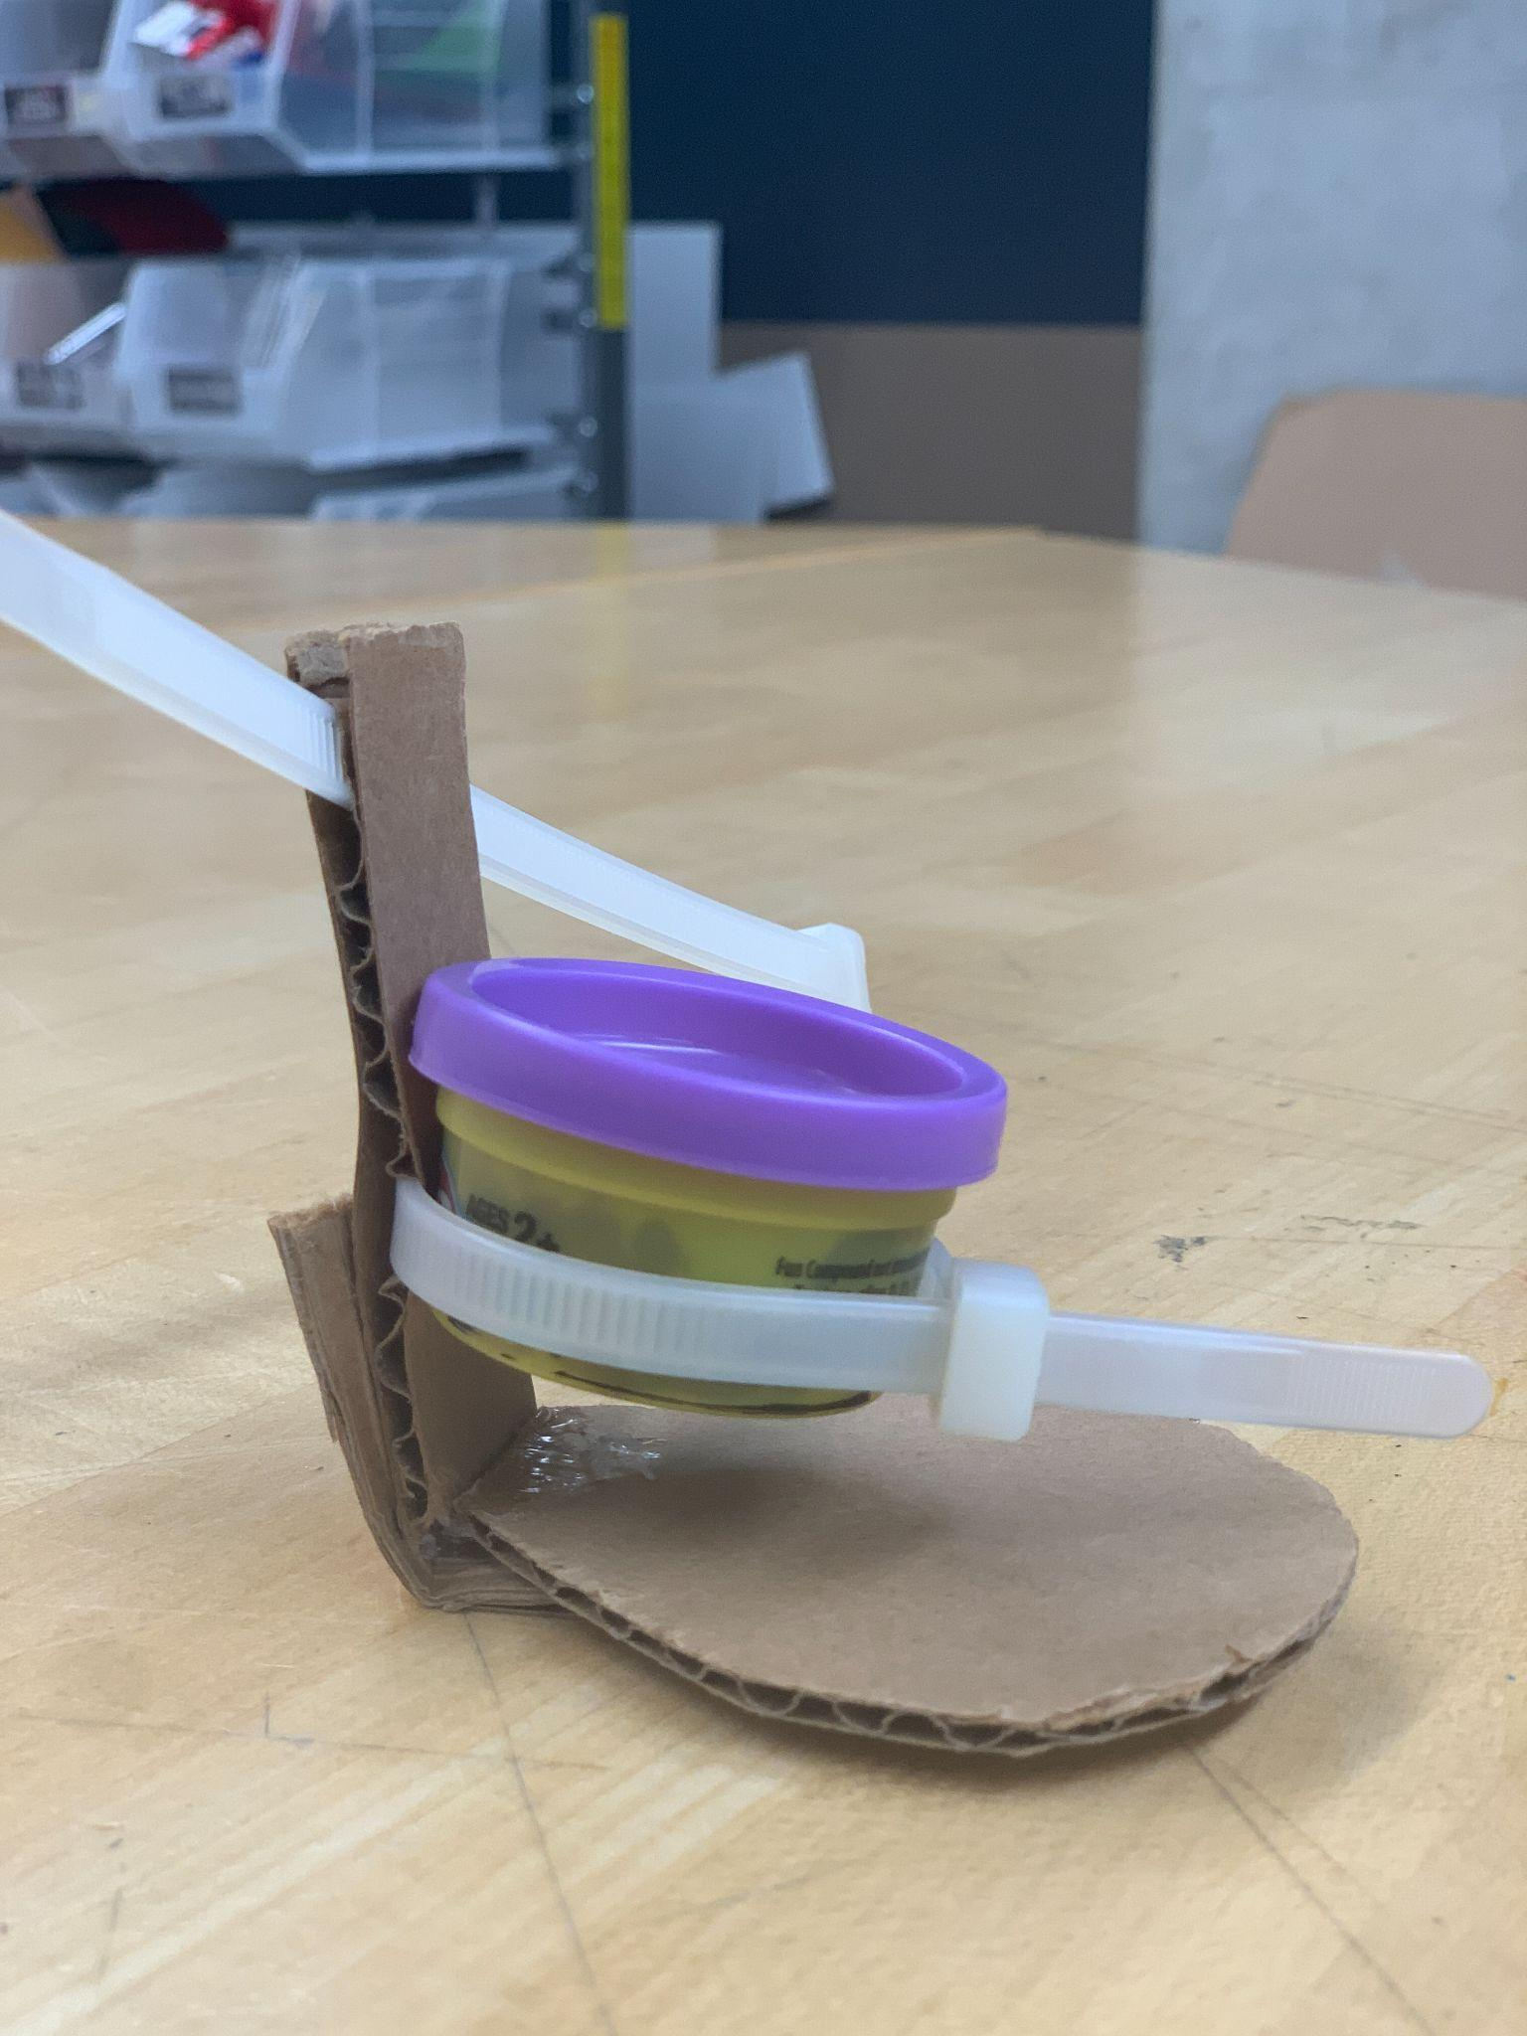The Zip Time Cup Holder attaches to the arm of the wheelchair and uses adjustable grip zip ties to secure the container in the cupholder, allowing the user to then open the container. The zip ties serve as a way to secure containers in an easy and simple way and to account for the variety of container sizes one encounters. The multipurpose nature of the device allows for one to use the device as a water bottle holder or for any other container, while still meeting the design needs. Figures XXX and XXX display the device without any container in place; note how the back zip tie or another clamping mechanism would be used to anchor the cup holder to his wheelchair. Figures XXX and XXX then illustrate how a container could be placed within the device and tightened to allow the user to remove the lid of the specified container.

Figure 21: A Front View of Zip Tie Cup Holder

#### Feedback:

Unfortunately, Megan and Randi were not able to look at this design and as a result, we did not get any feedback from them.

Figure 20: An Angled View of Zip Tie Cup Holder

### Rubber Clamp Cup Holder:

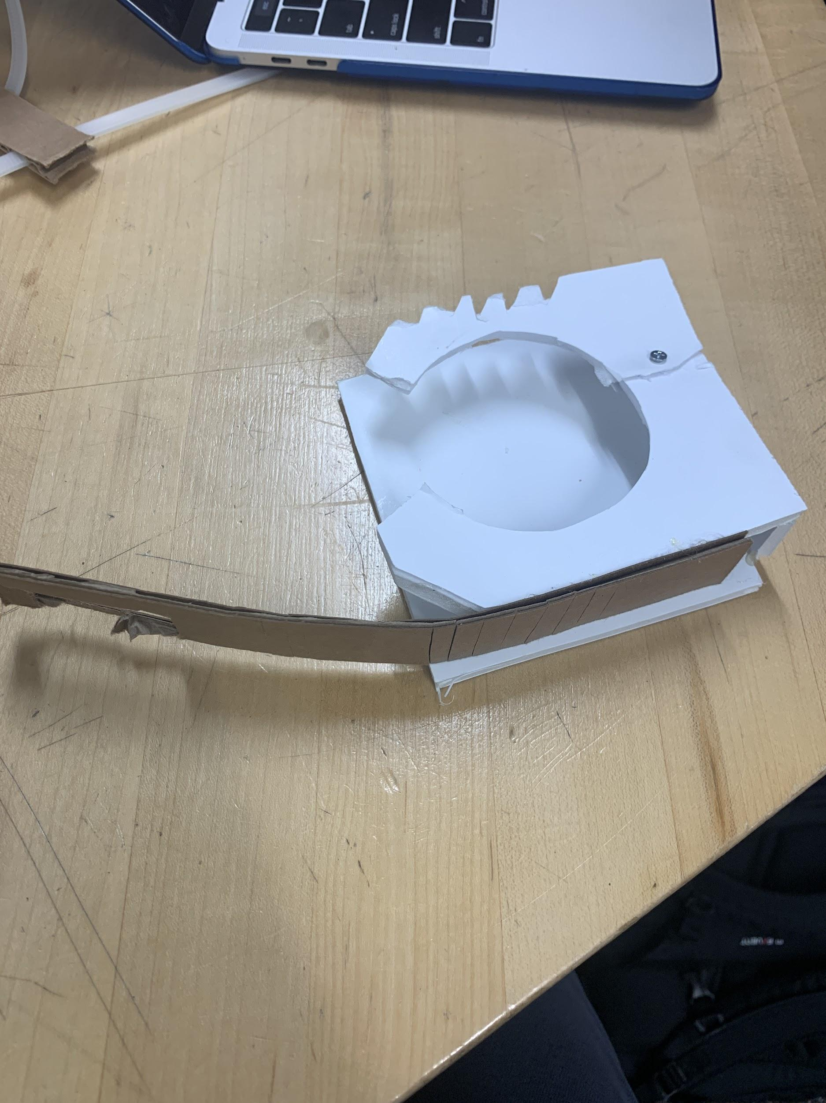

* Concept: Attaches to the arm of the wheelchair and uses adjustable rubber clamp to secure the container in place.
* Rationale: The rubber clamp serves in a similar fashion to the zip-tie as a way to secure containers in an easy and simple fashion while also accounting for the versatile sizes one could encounter (see Figure XXX). Once again, the device can serve both as a container holder for the user to open containers with and as a simple cup holder (Figures XXX and XXX). The main difference between the two designs comes in the locking / gripping mechanism. The zip tie allows for a more versatile container size while the rubber clamp has a stronger gripping mechanism and possibly be easier to latch as well.

Figure 22: A View of the Rubber Clamp Opened

#### Feedback:

* 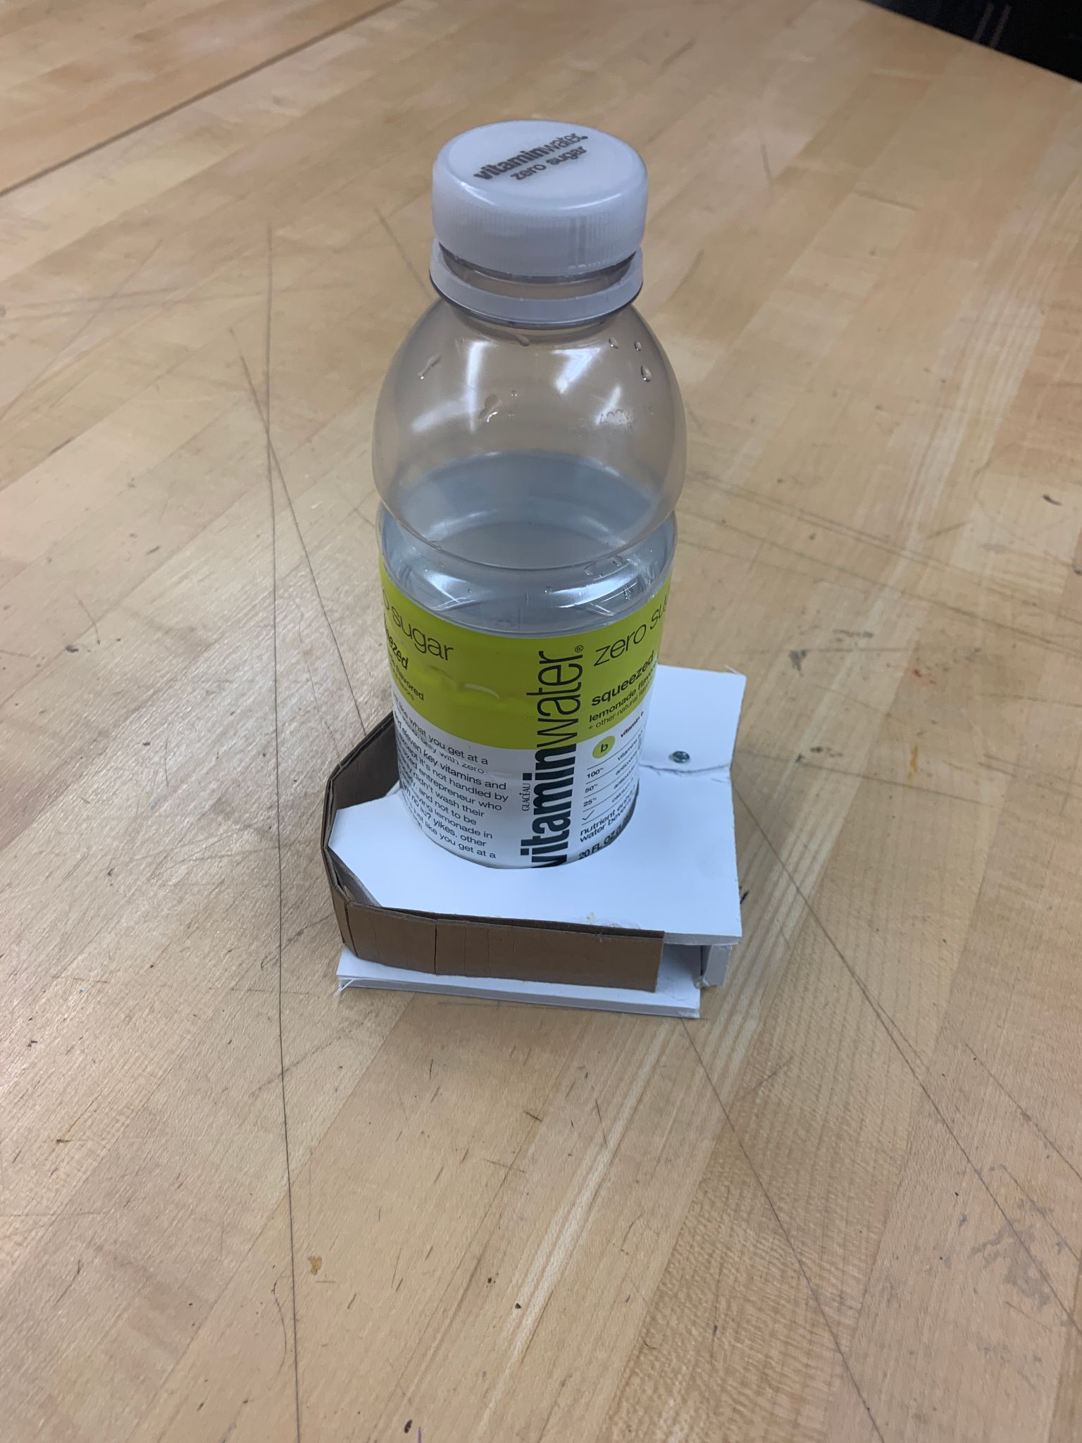Does the user have the fine motor skills for an adjustable strap?

Figure 23: A View of a Container Gripped by the Clamp

* + The project partner responded that he did have such skills to hook a strap but were concerned that the video showed the person utilizing two hands with the device rather than just one.
* Would the user be able to use a Velcro strap more effectively than a rubber one?
  + When asked if a Velcro strap might be an easier mechanism for the user, the project partners responded in favor of Velcro, but recommended having a hook on the end.
* Does the user already have a cup holder or other holding device on his wheelchair?
  + Not answered.
* If the device held a container firmly in place (i.e., pill bottle, peanut butter jar), would the user be able to unscrew the lid?
  + Not answered.

### The Air Pressure Device:

Figure 24:A Top View of the Air Pressure Device

* Concept: This device uses air pressure to secure a container in order for the user to be able to grip the top and twist or pop it off. The pressure would make the container sturdy enough to be able to grip it better, (see Figure XXX ) without damaging the container itself.
* Rational: This device would adapt to many different sizes and provide support in the process of opening containers. This device would meet the requirement of being small and portable and very easily operated since it would be automated for the user. It is versatile and efficient, while being discrete.

#### Feedback:

* Pros / Cons
* 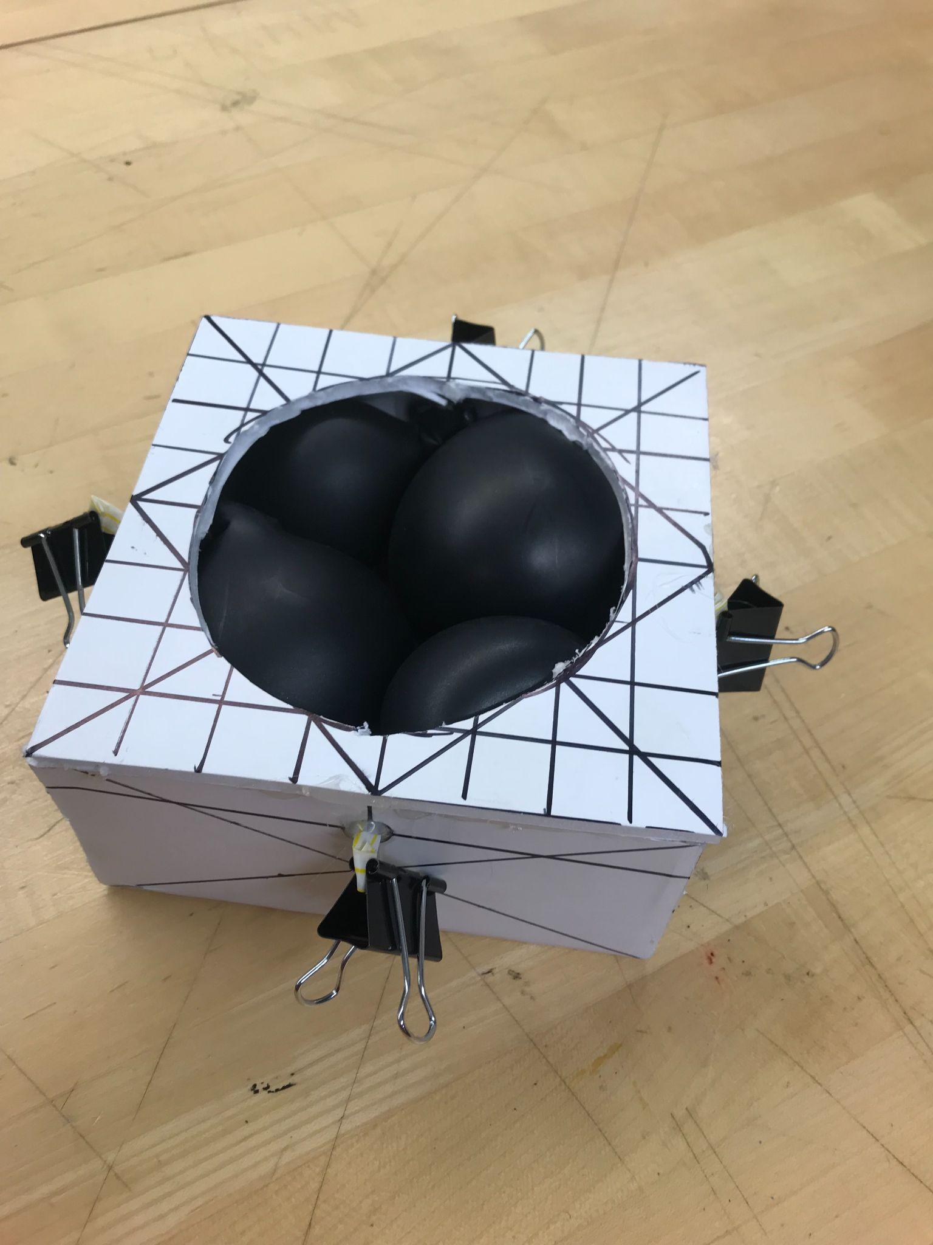“Pros: this is a cool idea! Would it adjust automatically to the size of the container”
* “Cons: might be hard to push the item into the small space with 1 hand”
* Regarding the size and weight of the mockup: What does the user believe to be an ideal size?
  + “Ideal size: doesn’t go outside of the width of the arm rests otherwise the user can’t fit through doorways. Yes, he can lift all those household items, roughly anything under 10#.”
* Could the user lift a couple common household items like: a tissue box, a bottle of ketchup, or a water bottle, in order to determine an approximate ideal weight for the product?

Figure 25: A Side View of the Air Pressure Device

* + “A milk jug is about the max he can lift.”
* Would the user be able to attach the bottom of the product to the wheelchair with Velcro with one hand?
  + “Velcro with one hand could be tough, maybe if the bottom of the box was sticky/could grip onto the arm rest without sliding off then he could probably do the Velcro.”

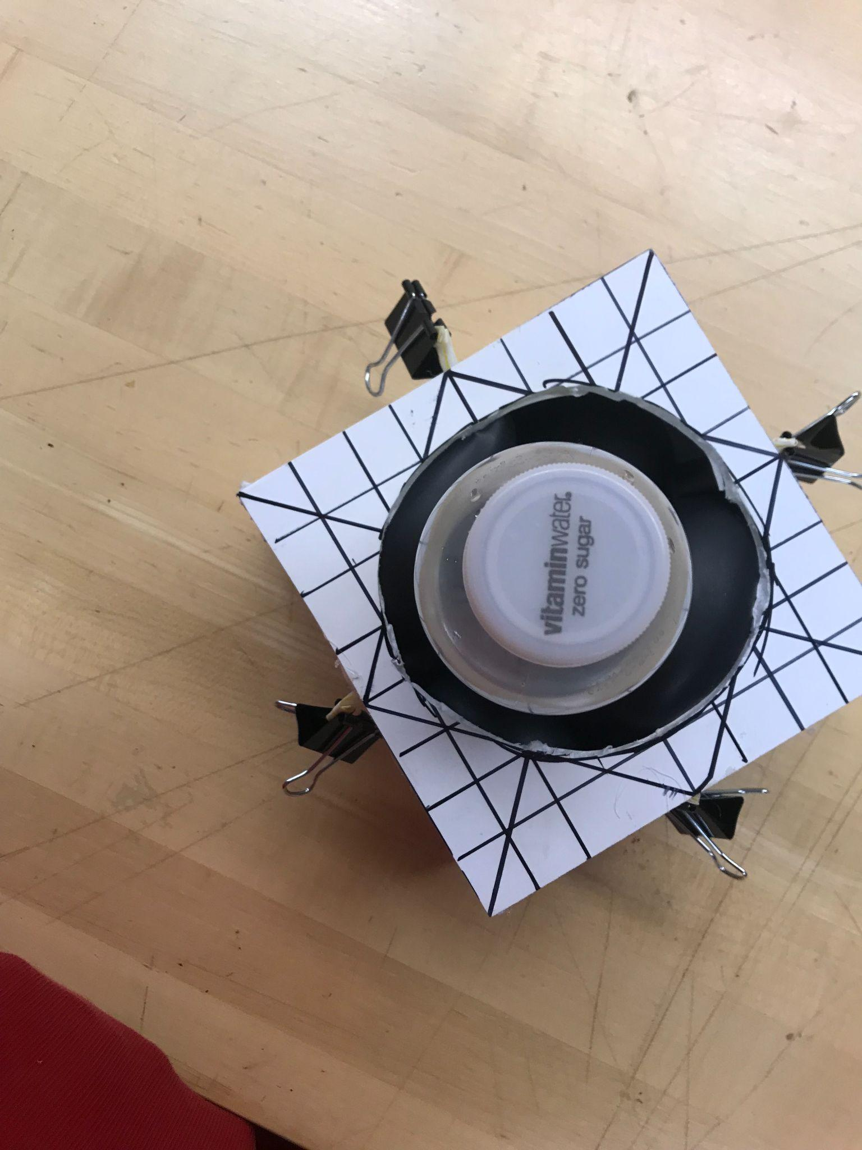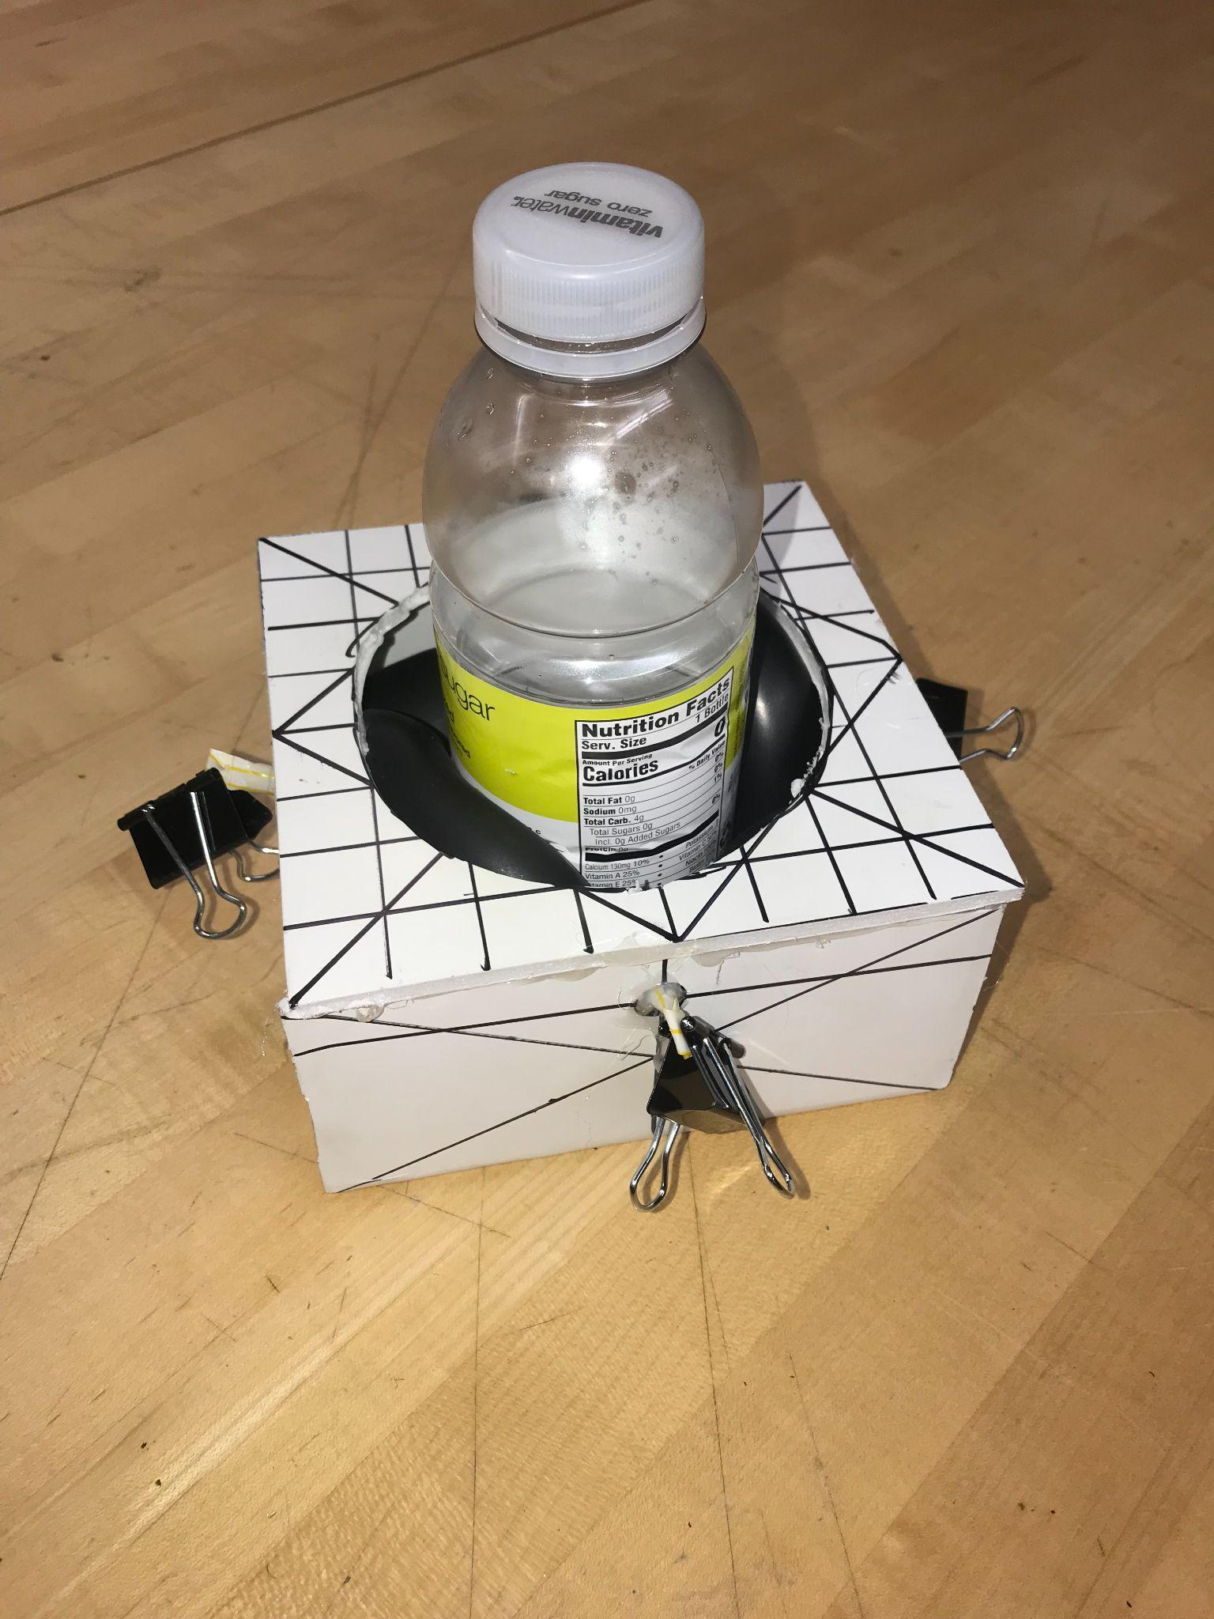

Figure 26: A Side View of the Air Pressure Device with a Container

Figure 27: A Top View of the Air Pressure Device with a Container

### The Clasp and Lock:

Figure 28: An Angled View of the Clasp and Lock

* Concept: It comes in two parts. There is an attachment to the lid of the container and an attachment to the hand (see Figure XXX). It works like the lock and key model, where the hand latches onto the clasp and twists to open the container.
* Rational: It works for multiple sizes of containers because it is only an attachment to the caps of the containers, and the grip is solved by clasping onto the attachment. It's easy to access and small in size. It is discrete and easy to clean.

#### Feedback:

* What motions is the user more comfortable with: pushing, pulling?
  + “It’s difficult to tell in the video but it seems like this requires decent strength in both arms?”
  + “He can push and pull with the right arm, but not with the left arm.”
* Is there any preference in size of the handle? Could we model the hand to make it comfortable specifically for the user?
  + “No size preference for handles.”
* Would the user prefer to attach a clasp to containers or for there to be a universal cap attachment for many different containers?
  + “Universal clasp seems like a lot of work to attach to all containers he’s trying to open.”

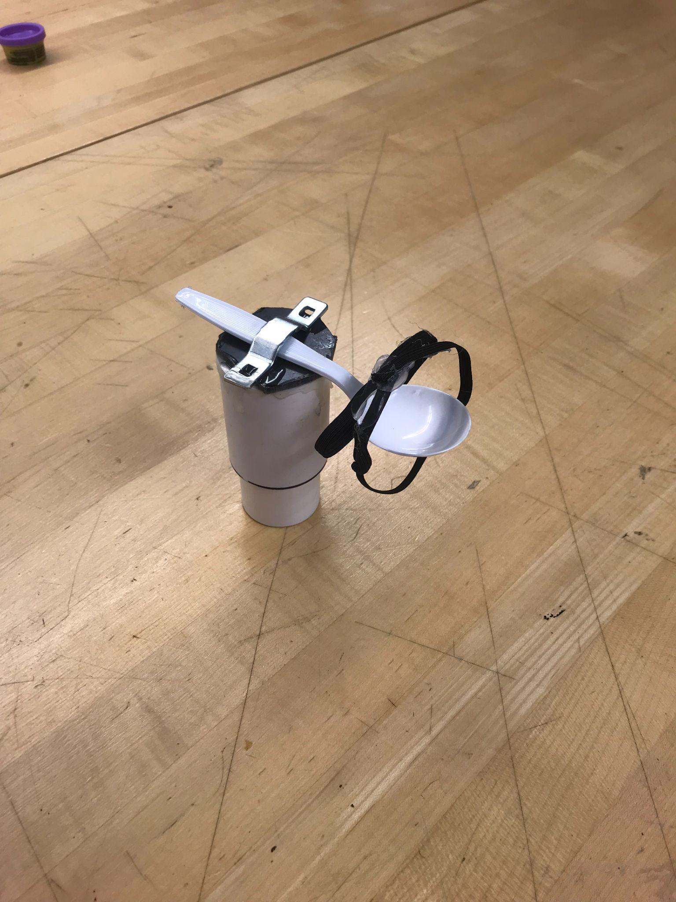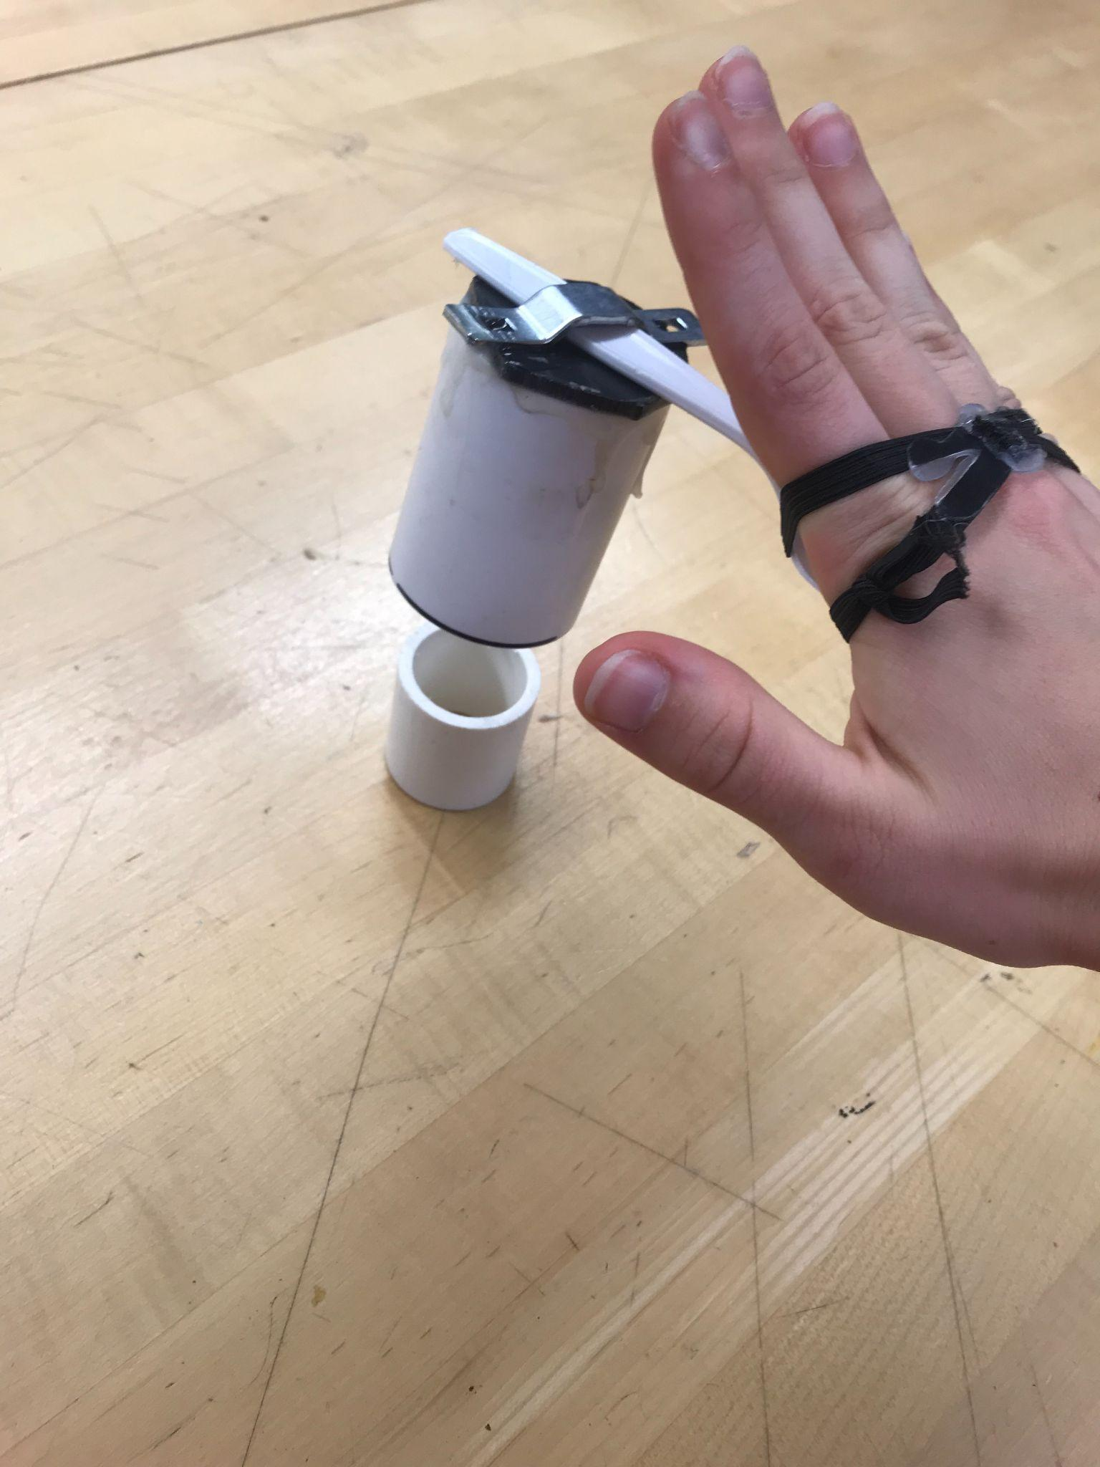

Figure 29: The Clasp and Lock in Resting Position

Figure 30: The Clasp and Lock Engaged

### The Tablelike Opener:

* Concept: This device, seen in Figure XXX, acts as a table to help stabilize a variety of containers. It attaches to the user's arm rests so it does not need to rest on our user’s lap as shown in Figure XXX. The top of the table is covered in double sided sticky tape to help grip the base of any container.

Figure 31: A Top View of the Tablelike Opener

* 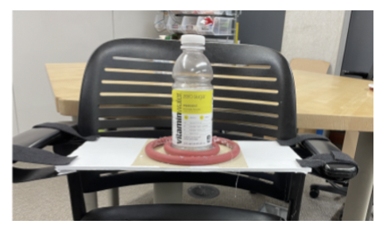Rationale: The user can rest the container on top and use his functioning hand to untwist the lid. None of the contents of the container will be spilled and it accommodates many sized containers as shown in Figure XXX.

#### Feedback:

* Pros / Cons
  + Pros: “looks easy to open with 1 hand”
  + Cons: “large, the tray could be in the way and he would have to remove and replace it more frequently.”

Figure 32: A Side View of the Tablelike Opener Engaged

* Is this motion comfortable for the user?
  + “Yes, it looks like a comfortable motion.”
* Is the size of this device too ideal or should our team try to make it more minimalistic?
  + “Probably should be more minimalistic or collapsible.”
* Does the user have trouble taking this device out of their bag?
  + “He is able to access his backpack by grabbing it off the back of the wheelchair, I’m not sure if this device would fit in the backpack though.”
* Does the user like or dislike the idea to attach this design to both of the arm rests? Would the user prefer if it was attached to just one arm rest?
  + Not answered

### The Underarm Rest Jar Opener:

Figure 33: A Front View of the Underarm Rest Jar Opener

* Concept: This device, seen in Figure XXX, helps to grip the lid of any size container to help unscrew it. It attaches underneath the user's arm rests with Velcro as shown in Figures XXX and XXX.
* Rationale: It has a V shape opening device that applies tension to the lid as shown in Figure XXX. This way the lid accommodates any size of a top. The user simply puts the lid to where it fits snuggly and twists the bottle to get the lid to untwist, seen in Figure XXXX

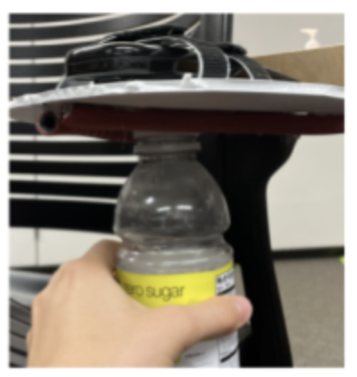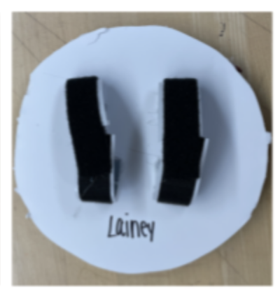

Figure 34: A Top View of the Underarm Rest Jar Opener

Figure 35: The Underarm Rest Jar Opener Engaged

#### Feedback:

* Pros: “nice that it is easily attachable to arm rest and able to remove if needed”
* Cons: “might be awkward to reach around the armrest to access this and apply pressure upwards towards the arm rest to use it, but it could work!”

## Iteration:

While reviewing the feedback from Meghan and Randi, we realized that a practical, functional solution would incorporate the values of compactness, accessibility, and minimalistic. We found that if there is an attachment to the arm of the wheelchair it has to be facing up. Reaching under the arm rest is an awkward motion that we should avoid, because the user has to manage to fit his arm, legs, and container within the tiny space spanned by the armrest and wheelchair. Moreover, we want the user to have a full view of the motion, and the user could potentially lose the lid, too, if it falls. The user could access the region above the arm rest more readily and therefore we must prioritize the mockups that consider this. Main concerns regarded the potential weight of the product and the independence that it could bring to the user. Some tasks like using Velcro as a way to attach a possible device to a chair require two hands to set in place as it is a hard one-handed operation. This decreases the amount of independence that the user has and therefore should be avoided. The product should be easily attachable and graspable, which means no Velcro.

## Discussion:

After deliberation, our group decided on two final concepts. Our deliberation first eliminated the solutions that we thought to be bulky or that resulted in awkward motions. The “Tablelike Opener” was eliminated due to its large size and position in the user’s lap, and the “Rocking Ratchet Wrench” was removed due to the bulkiness and impracticality of the handle. Moreover, we put aside the solutions that would be conducive for two-handed motion, which we know the user cannot do. That eliminated the “Clasp and Lock” and “Zip Time Cup Holder” solutions. The “Rubber Clamp Cup Holder” was eliminated simply because we believed our other solutions were superior. That leaves us with two plausible solutions: one is the Container Opener with Air Pressure (COWAP) device, which combines the “Criss Cross Container DeCoupler” and the “Air Pressure Device.” The COWAP builds on an existing blood pressure sphygmomanometer (pump) to provide adequate air pressure to secure the container in a base, and the ratcheting conical top can provide extra torque and friction to open a vast set of container sizes. The second solution has been coined “The Instant Container Opener,” which is a modification of the “Underarm Jar Opener.” This device will attach opposite the user’s dominant arm to provide more leverage and more natural movements. Further performance testing is necessary for this solution in order to determine its practicality.

# Appendix L: Design Review Summary

## Design Review 1: Feedback from Project Partners

### Methodology

We shared our design, MiCO, my instant container opener, a product that enhances the capabilities of the under the counter opener, in class on Date and time. We explained how MiCO attaches to the wheelchair with a Velcro strap that is looped for easy application and removal. It has a V shaped opening and steel teeth that allow for efficient and versatile use.

The reviewers were given a questionnaire to answer questions about specific areas of the design to build a more solid concept. Questions focused on accessibility and easiness of use, as well as the most effective method of attachment to the wheelchair, and the limitations that the product could have.

Table 7: Design Review Summary

|  |  |  |  |  |
| --- | --- | --- | --- | --- |
| **Reviewers like** | **Reviewer’s dislike** | **Features to be added** | **Features to be removed** | **Additional comments/ questions** |
| **The accessibility of the design**  It is straightforward and easy to use.  **The detachable feature**  The fact that it is removable with ease  **Its effectiveness** Because it is an enhances product based on one that works, it seems like it will be useful | **The safety factors**  How it will be stored to prevent danger to the user  **The comfort of the motion**  The position of the device might not be optimal for comfort for the user  **Where the lids go**  The product may cause a lid to fall off causing a further inconvenience | A cap or a case to prevent danger to the user. It must be easy to place with one hand.  The position of the device may be modified and put diagonally in front, but performance testing is required  The device could hold the cap in place, but it is meant to break the seal and make it easier to open with one hand, without removing the cap | The plastic could be not sturdy enough, so it could be a factor to replace and consider another material  We narrowed down that it will be attached with looped Velcro, which means that rubber clamps or adjustable zip ties will no longer be considered for use. | There should be performance testing to see if it will slide down the arm and to make sure it is secure and easy to use.  How will the velcro attach to the device itself?  Does it extend past the wheelchair? How would the size be adjusted? |

### Plan to address these reviews:

There will be performance testing with the product. Multiple EZ container openers will be bought in order to be able to choose the most effective and efficient product from a variety of methods of attachment and positions relative to the wheelchair. We will also develop a cover or a case that will ensure the safety of the user. The reviewers agreed that the looped Velcro was the best way to attach the device, but we still have to determine what the optimal position and attachment to the device itself is. We will achieve this by testing different methods, like drilling the plastic or a superglue epoxy. If the comfort of the motion is not optimal, we will adjust the position by adding an extension to the wheelchair arm or develop another method of keeping MiCO sturdy while keeping the user comfortable. Regarding the size, we have a plan to reduce it and it would not stick outside of the arm rest.

# Acknowledgements

# References

[1] “BIOMECHANICS OF THE HAND.” https://ouhsc.edu/bserdac/dthompso/web/namics/hand.htm (accessed Oct. 07, 2021).

[2] “Body Anatomy: Upper Extremity Muscles | The Hand Society.” https://www.assh.org/handcare/safety/muscles (accessed Oct. 07, 2021).

[3] P. Goetti, P. J. Denard, P. Collin, M. Ibrahim, P. Hoffmeyer, and A. Lädermann, “Shoulder biomechanics in normal and selected pathological conditions,” EFORT Open Rev., vol. 5, no. 8, pp. 508–518, Sep. 2020, doi: 10.1302/2058-5241.5.200006.

[4] N. Jacewicz, “Millennials May Be Losing Their Grip,” NPR, Jun. 13, 2016. Accessed: Oct. 07, 2021. [Online]. Available: https://www.npr.org/sections/health-shots/2016/06/13/481590997/millennials-may-be-losing-their-grip

[5] “Grip and Manipulation,” p. 9.

[6] “Osteoarthritis - Diagnosis and treatment - Mayo Clinic.” https://www.mayoclinic.org/diseases-conditions/osteoarthritis/diagnosis-treatment/drc-20351930 (accessed Oct. 07, 2021).

[7] L. E. Jones-Engel and K. A. Bard, “Precision grips in young chimpanzees,” Am. J. Primatol., vol. 39, no. 1, pp. 1–15, 1996, doi: 10.1002/(SICI)1098-2345(1996)39:1<1::AID-AJP1>3.0.CO;2-2.

[8] “Arthritis | CDC,” Nov. 03, 2020. https://www.cdc.gov/chronicdisease/resources/publications/factsheets/arthritis.htm (accessed Oct. 07, 2021).

[9] “The Known and Unknown of Stroke Infographic,” *www.stroke.org*. https://www.stroke.org/en/professionals/stroke-resource-library/post-stroke-care/the-known-and-unknown-of-stroke-infographic (accessed Oct. 07, 2021).

[10] “Stroke Information Page | National Institute of Neurological Disorders and Stroke.”

https://www.ninds.nih.gov/Disorders/All-Disorders/Stroke-Information-Page (accessed Oct. 11, 2021).

[11] “Post-Stroke Rehabilitation Fact Sheet | National Institute of Neurological Disorders and Stroke.” https://www.ninds.nih.gov/Disorders/Patient-Caregiver-Education/Fact-Sheets/Post-Stroke-Rehabilitation-Fact-Sheet (accessed Oct. 07, 2021).

[12] L. Rasulić *et al.*, “MANAGEMENT OF BRACHIAL PLEXUS MISSILE INJURIES,” *Acta Clin Croat*, vol. 57, no. 3, pp. 487–496, Sep. 2018, doi: 10.20471/acc.2018.57.03.12.

[13] “Occupational Therapy,” Dycem. https://Dycem-ns.com/occupational-therapy (accessed Oct. 07, 2021).

[14] “Opening Jars with Arthritis: 21 Tips from Occupational Therapists to Make It Easier,” CreakyJoints, Jan. 07, 2020. https://creakyjoints.org/living-with-arthritis/how-to-open-jars-with-arthritis/ (accessed Oct. 07, 2021).

[15] tel-editors, “Best Jar Opener for Older Adults,” Tech-enhanced Life, Oct. 14, 2015. https://www.techenhancedlife.com/explorers/best-jar-opener-older-adults (accessed Oct. 07, 2021).

[16] “Automatic Jar & Can Openers | Disability Network Southwest Michigan,” Feb. 08, 2016. https://www.dnswm.org/automatic-jar-can-openers/ (accessed Oct. 07, 2021).

[17] “Brachial Plexus Injuries Information Page | National Institute of Neurological Disorders and Stroke.” https://www.ninds.nih.gov/Disorders/All-Disorders/Brachial-Plexus-Injuries-Information-Page (accessed Oct. 07, 2021).

[18] M. M. Samardzic, L. G. Rasulic, and D. M. Grujicic, “Gunshot injuries to the brachial plexus,” *J Trauma*, vol. 43, no. 4, pp. 645–649, Oct. 1997, doi: [10.1097/00005373-199710000-00014](https://doi.org/10.1097/00005373-199710000-00014).

[19] Pamolon, Round Silicone Trivets, model: YQ-1250.

[20] Mondolfo, L. F. Aluminum Alloys: Structure and Properties. Elsevier, 2013.

[21] Saravanan Murugan, Dhrumika Patel, Kinjal Prajapati, Madhuri Ghoghari, Pranjali Patel. Grip strength changes in relation to different body postures, elbow and forearm positions. Int J Physiother Res 2013; 04:116-21.

[22] J. Owen, Degradation and Stabilisation of PVC. Springer Science & Business Media, 2012.

[23] S. C. Shit and P. Shah, “A Review on Silicone Rubber,” Natl. Acad. Sci. Lett., vol. 36, no. 4, pp. 355–365, Aug. 2013, doi: 10.1007/s40009-013-0150-2.

[24] S. Derler, R. Huber, F. Kausch, and V. R. Meyer, “Effectiveness, durability and wear of anti-slip treatments for resilient floor coverings,” Safety Science, vol. 76, pp. 12–20, Jul. 2015, doi: 10.1016/j.ssci.2015.02.002.

[25] “What noises cause hearing loss?,” *Centers for Disease Control and Prevention*, 07-Oct-2019. [Online]. Available: https://www.cdc.gov/nceh/hearing_loss/what_noises_cause_hearing_loss.html. [Accessed: 14-Oct-2021].